**REPORT**

**Srikar Madarapu**

**PARKINSONS TELEMONITORING**

**Table of Contents**

**Introduction**  **2**

**Exploratory Data Analysis 3-13**

Histogram

Scatter Plot

Pearson Correlation matrix

**Model Evaluation and Selection 14-31**

Full model with outliers and influential points

Final model

**Model Validation** **31-35**

Splitting data to train and test

Train data

Test data

Frequency table of test data

**Method 2: Without log transform 35**

**Future Work**  **37**

**Code 37**

**Introduction**

The Parkinson's telemonitoring dataset contains information on individuals participating in a telemonitoring program for Parkinson's disease. It includes demographic details, such as age and gender, as well as clinical scores related to motor function and overall disability. The dataset also captures various vocal features, such as measures of fundamental frequency and amplitude variation, noise-to-harmonics ratio, and nonlinear complexity measures. These variables provide valuable insights into the condition of Parkinson's patients and can help in remote monitoring and management of the disease.

The Dataset contains 5875 observations and we consider dependent variables = Motor UPDRS and other varibales are

* subject# - Integer that uniquely identifies each subject
* age - Subject age
* sex - Subject gender '0' - male, '1' - female
* test_time - Time since recruitment into the trial. The integer part is the number of days since recruitment.
* motor_UPDRS - Clinician's motor UPDRS score, linearly interpolated
* total_UPDRS - Clinician's total UPDRS score, linearly interpolated
* Jitter(%),Jitter(Abs),Jitter:RAP,Jitter:PPQ5,Jitter:DDP - Several measures of variation in fundamental frequency
* Shimmer,Shimmer(dB),Shimmer:APQ3,Shimmer:APQ5,Shimmer:APQ11,Shimmer:DDA - Several measures of variation in amplitude
* NHR,HNR - Two measures of ratio of noise to tonal components in the voice
* RPDE - A nonlinear dynamical complexity measure
* DFA - Signal fractal scaling exponent
* PPE - A nonlinear measure of fundamental frequency variation

**Exploratory Data Analysis**

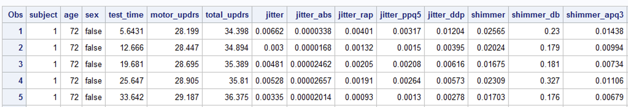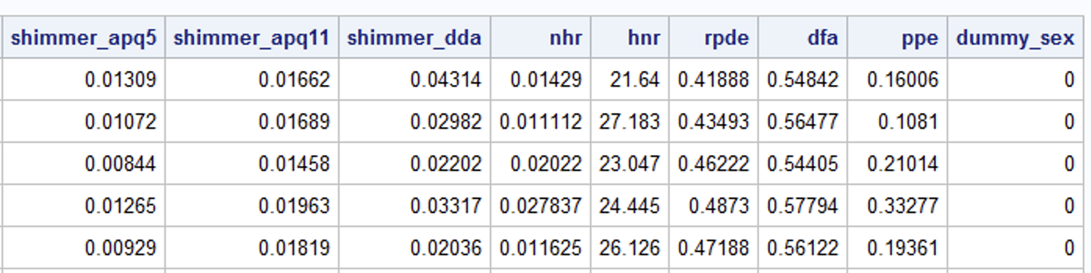

**HISTOGRAM**

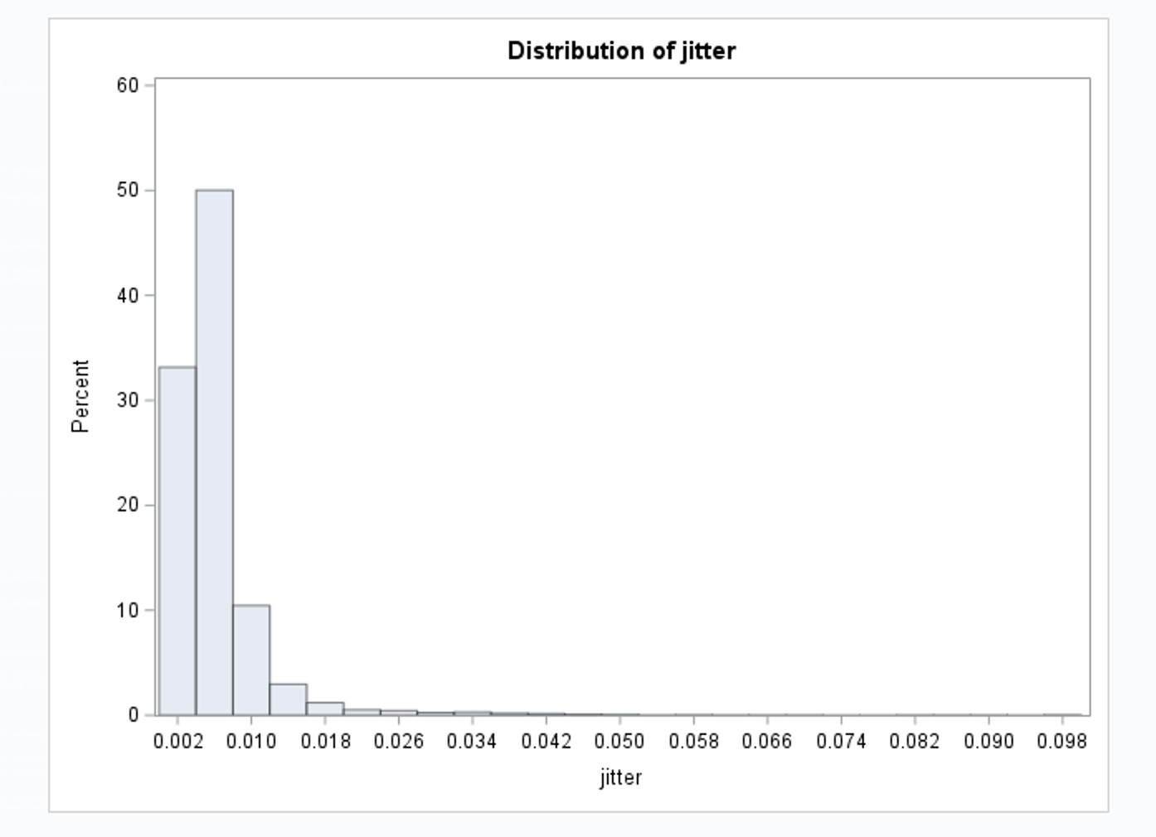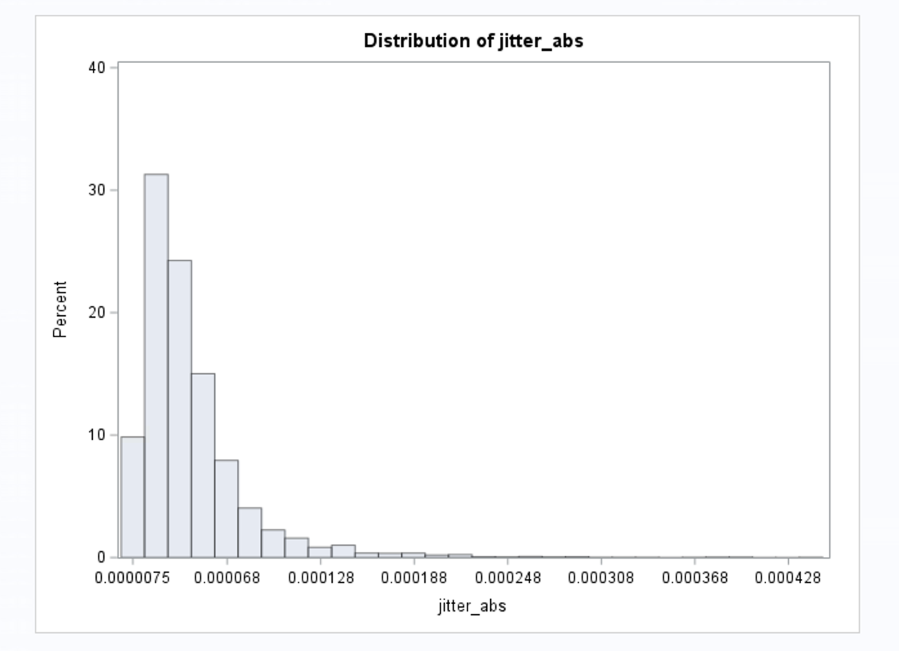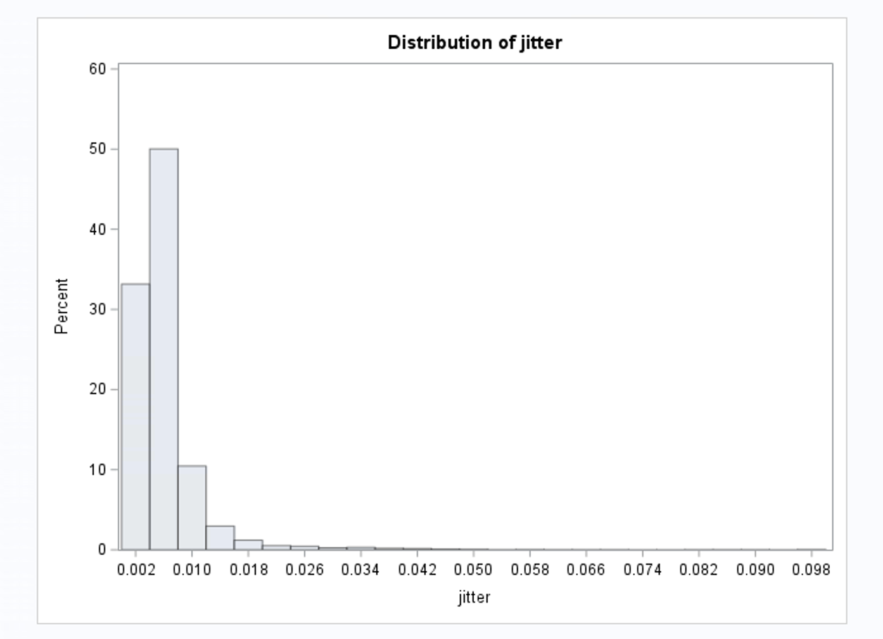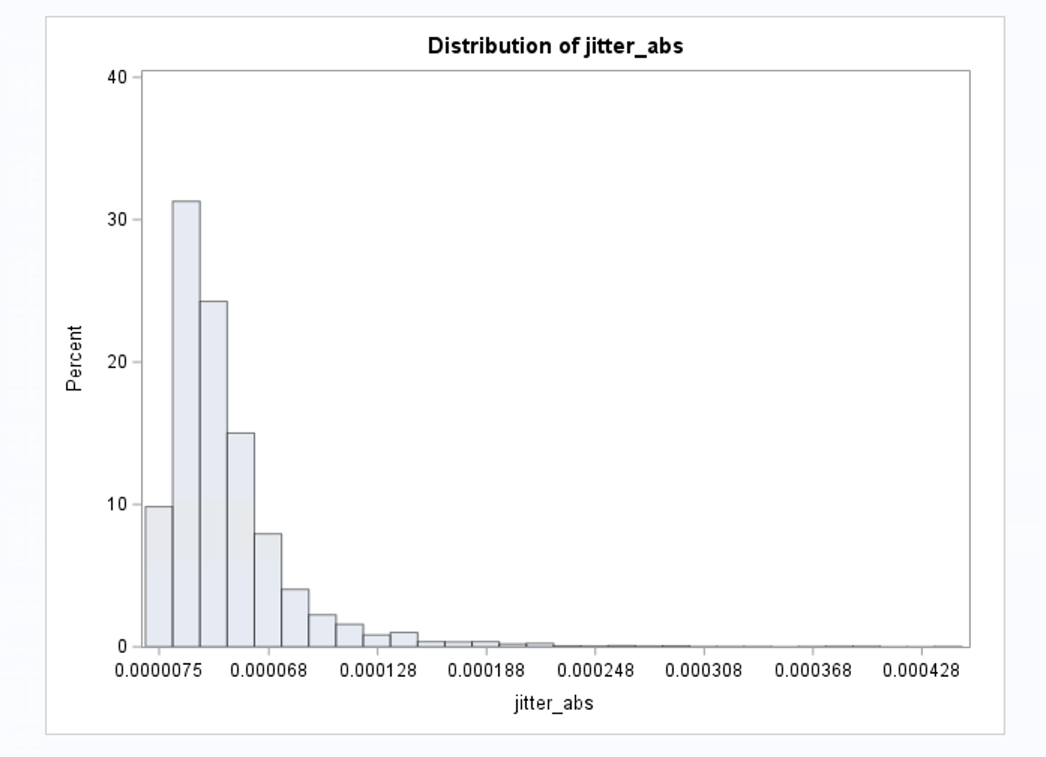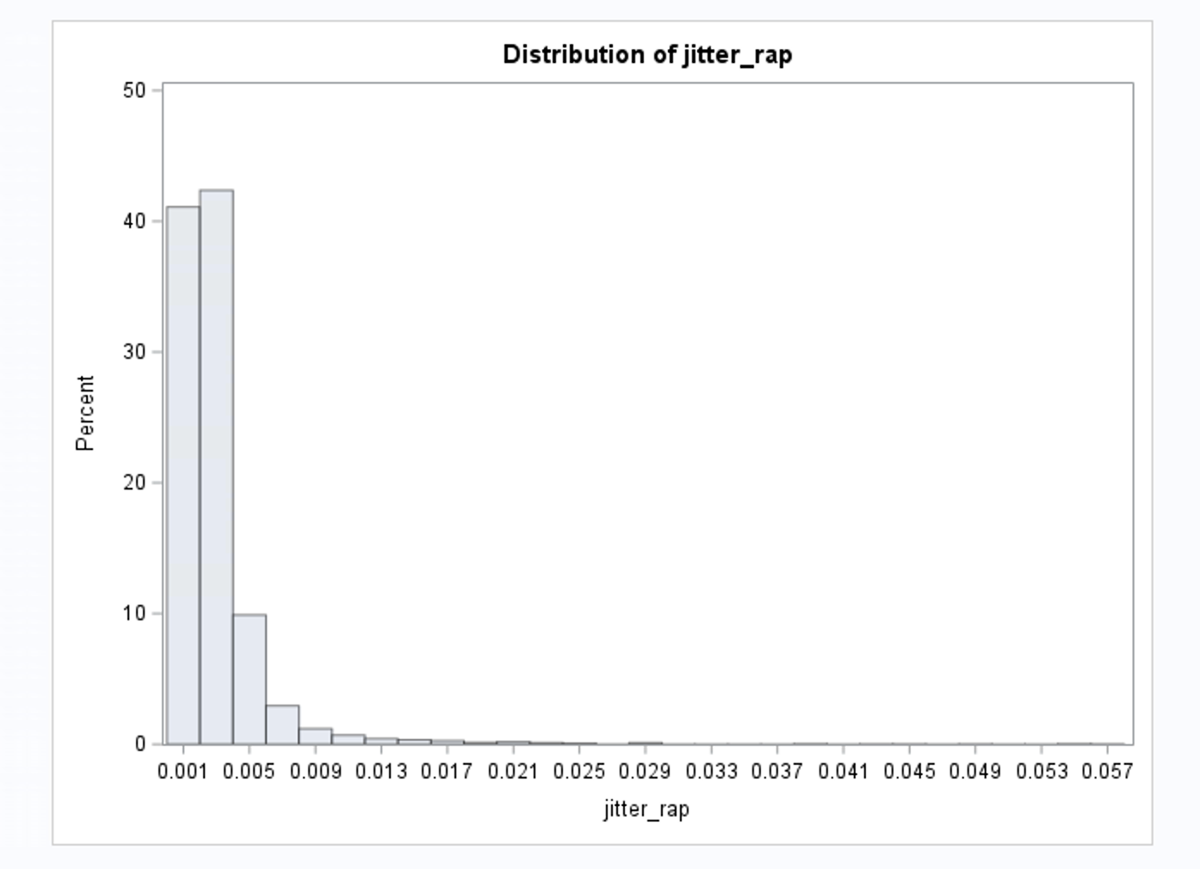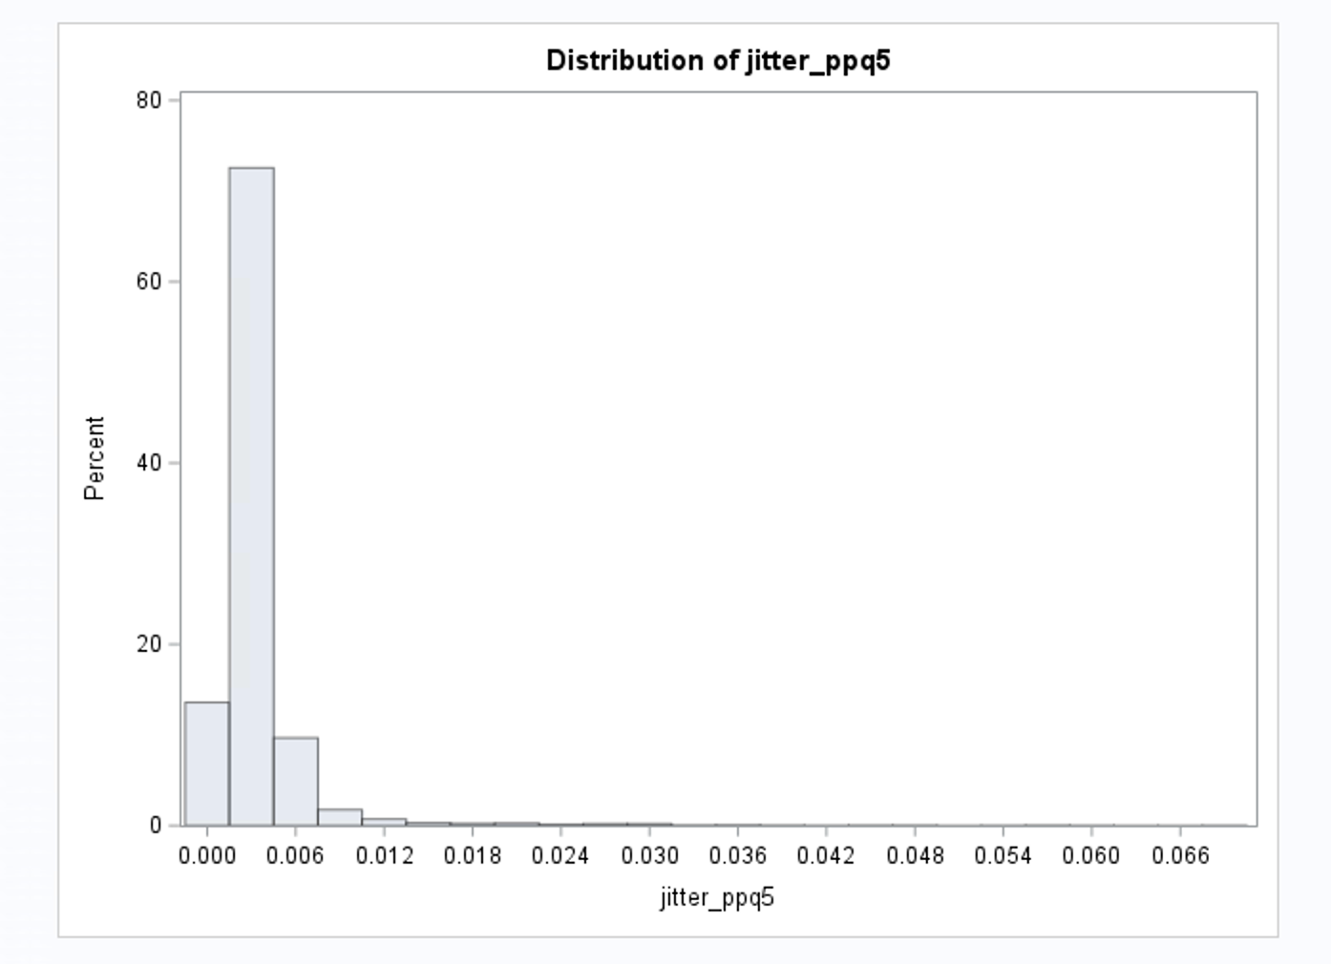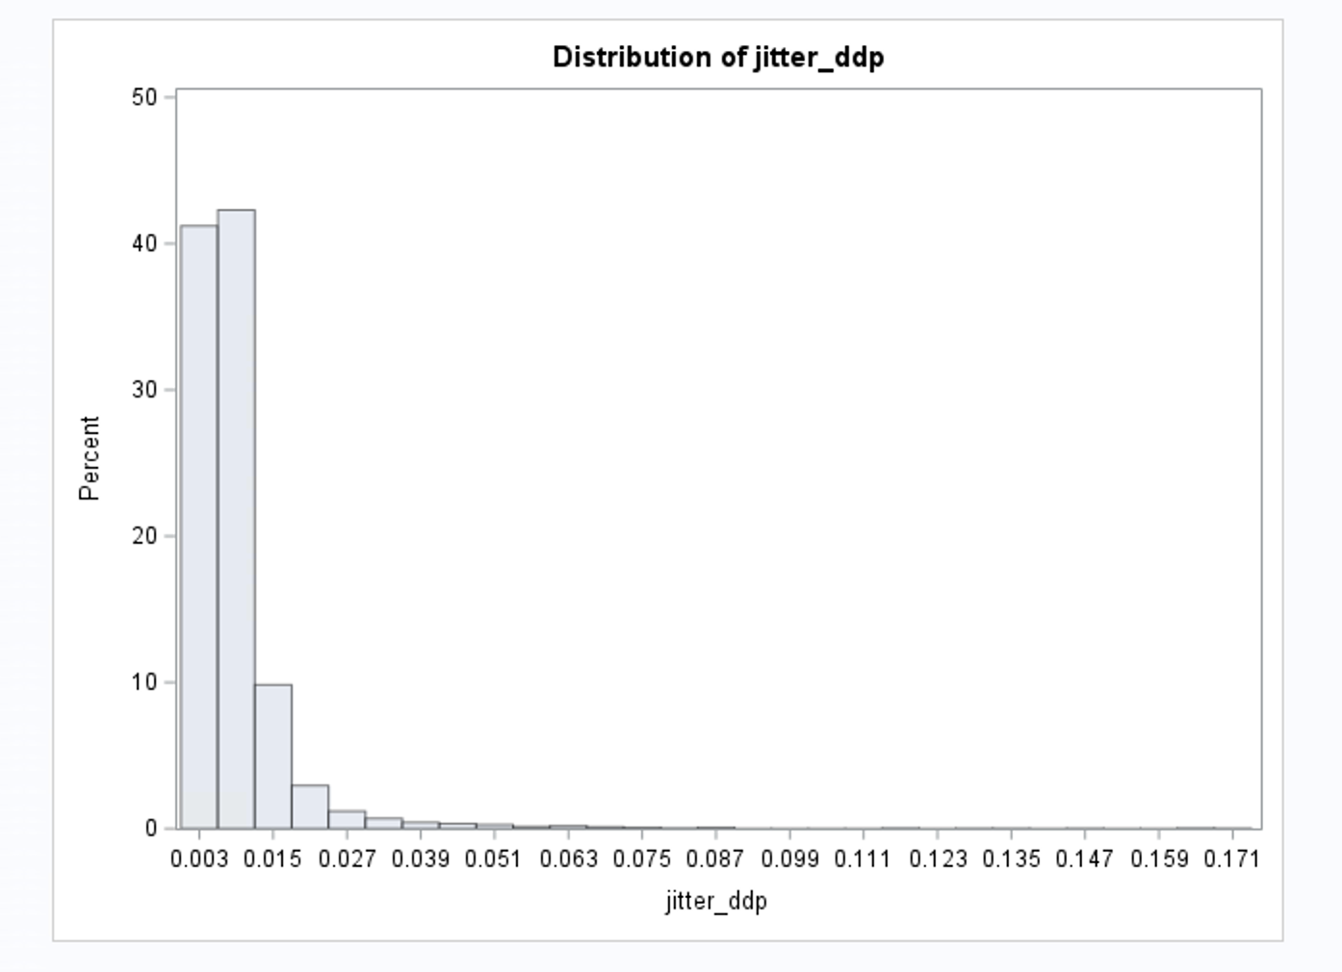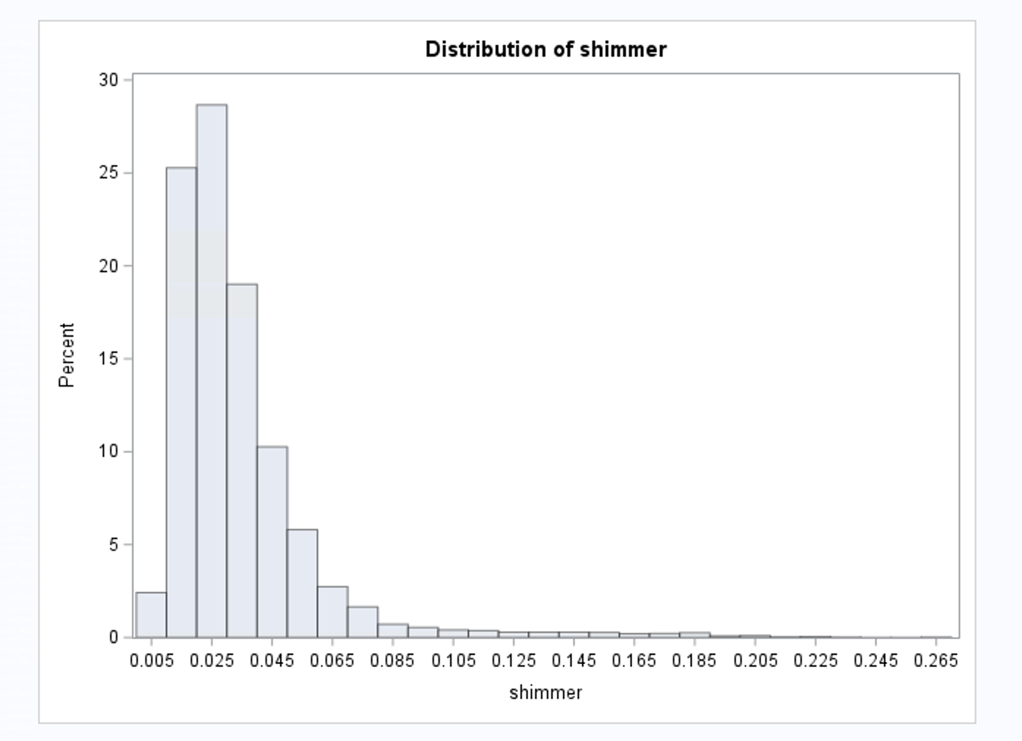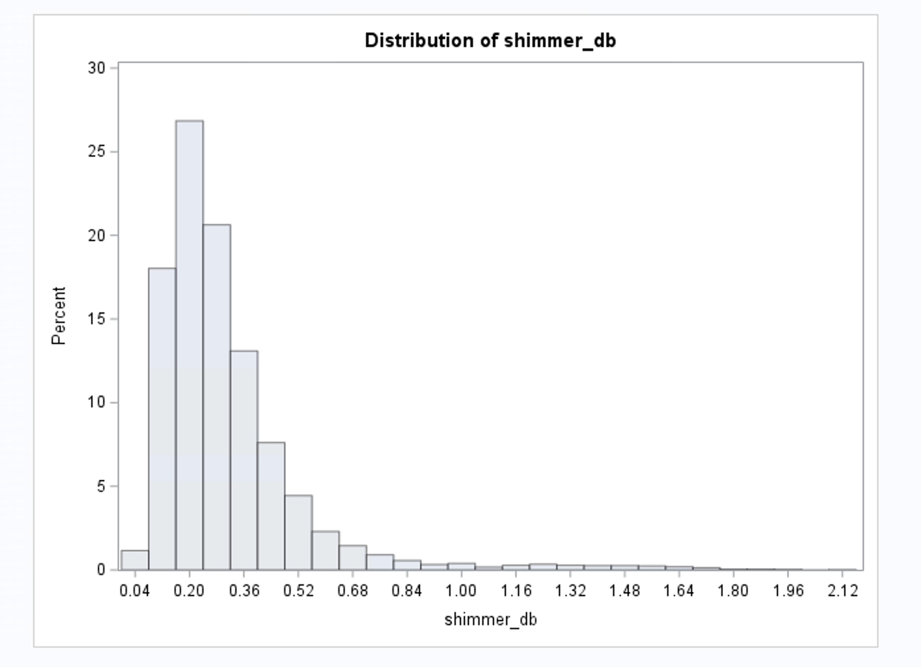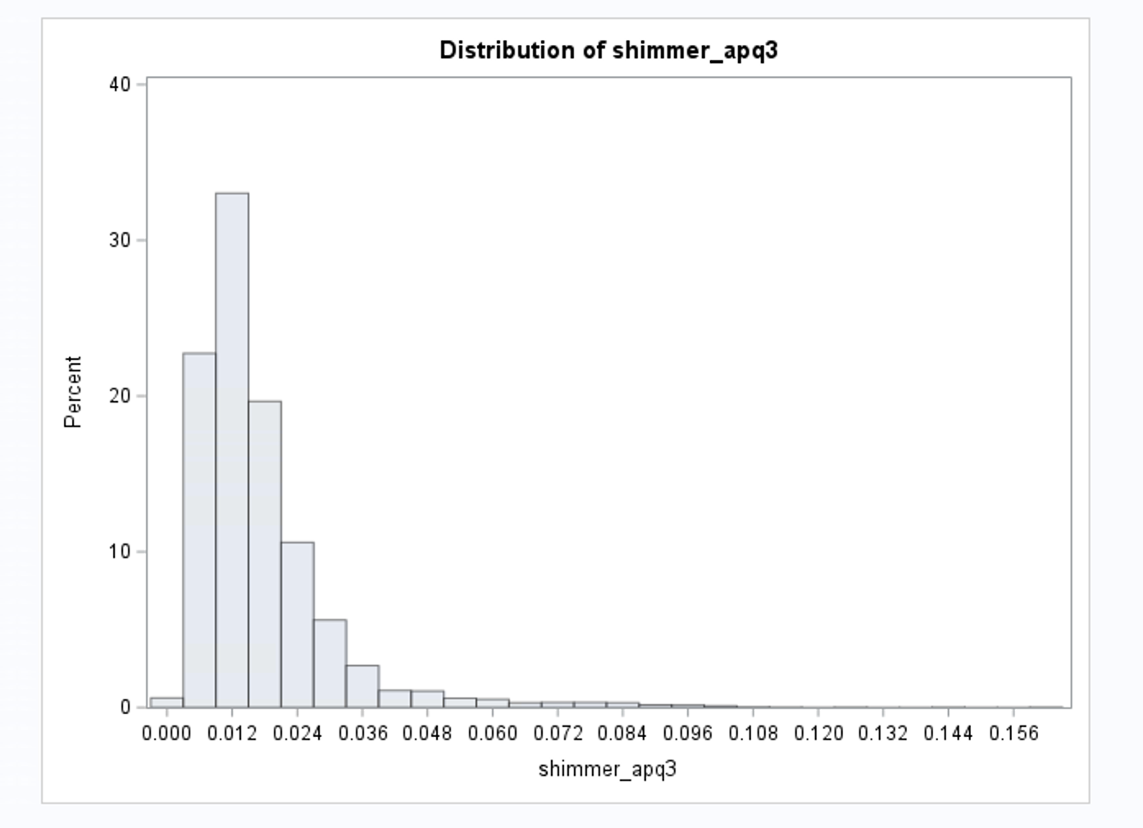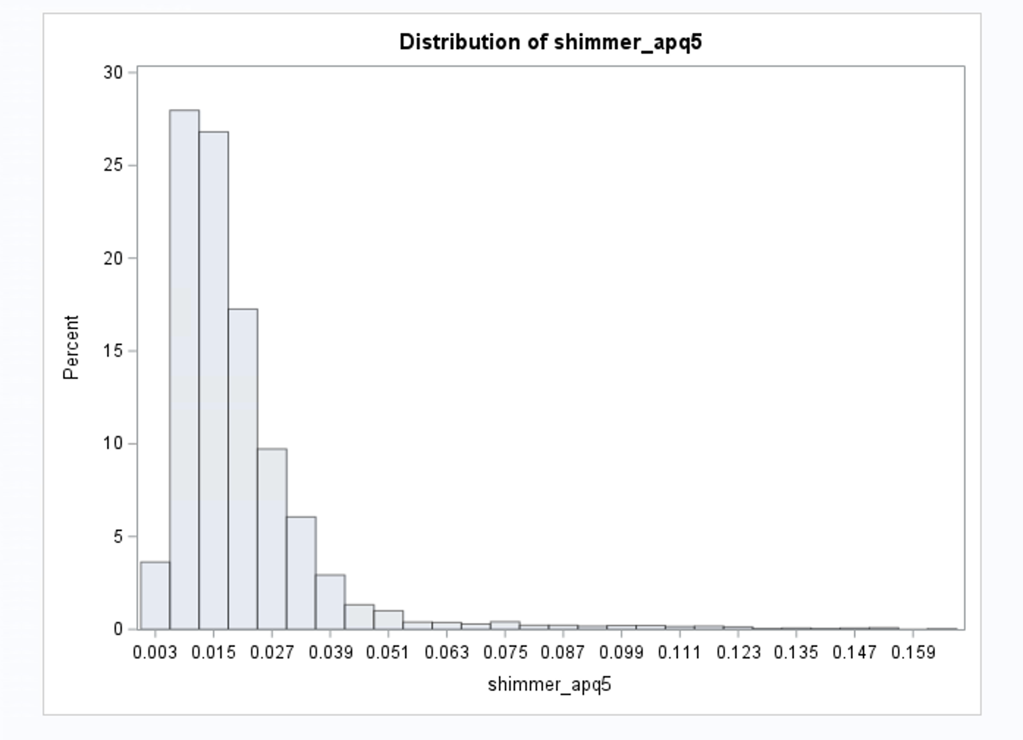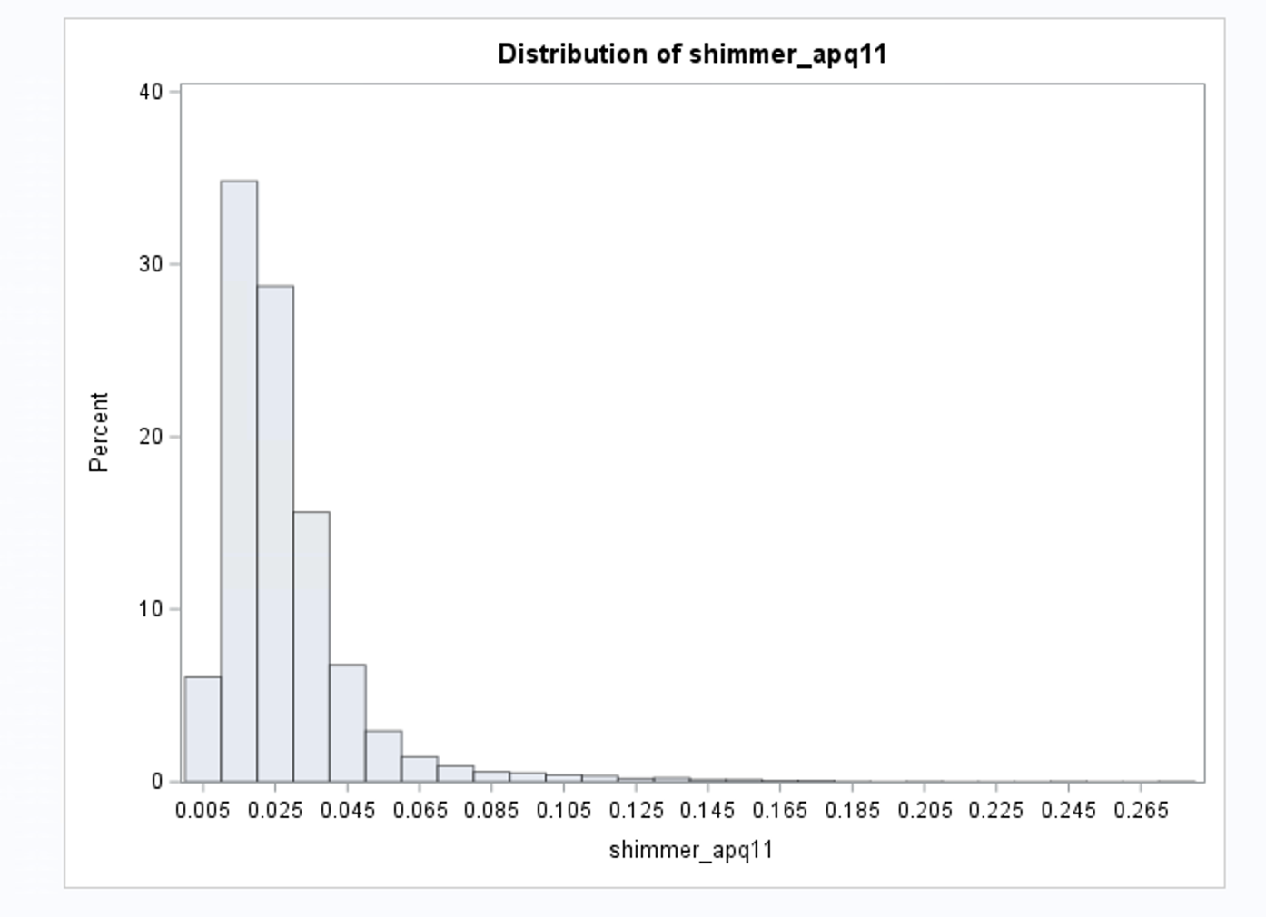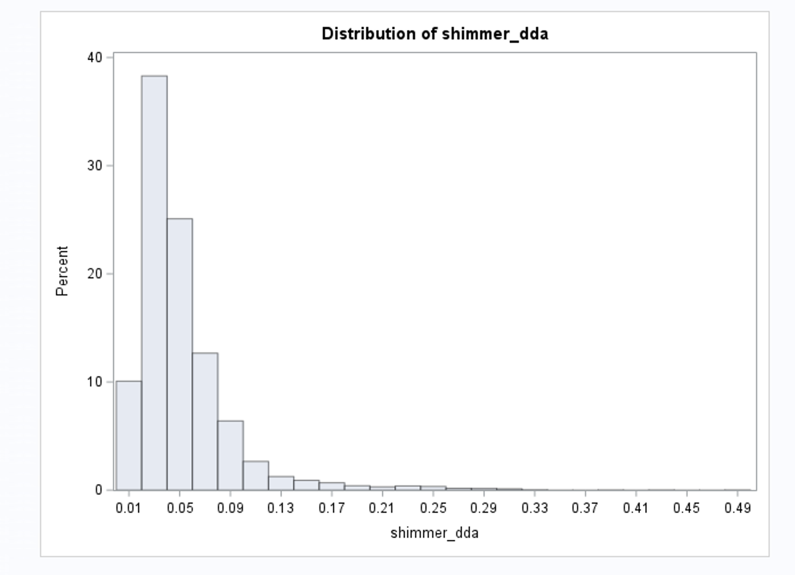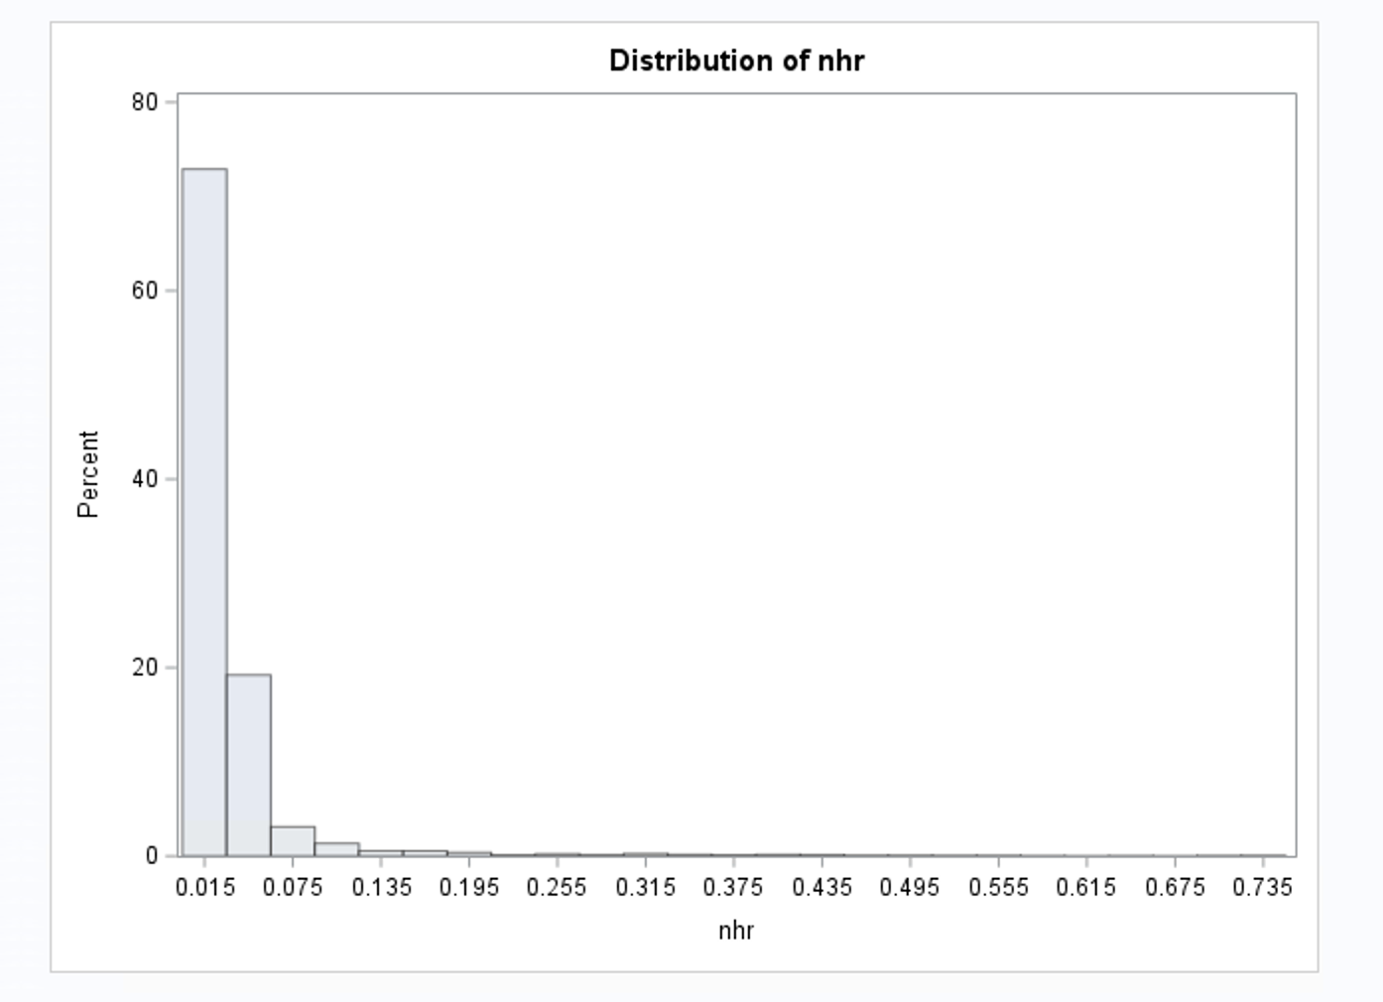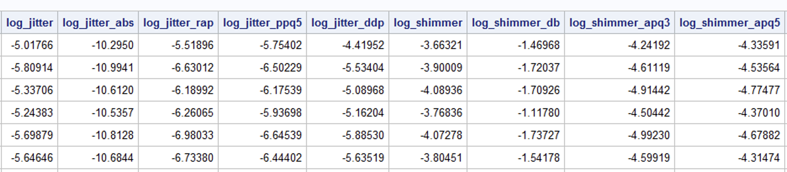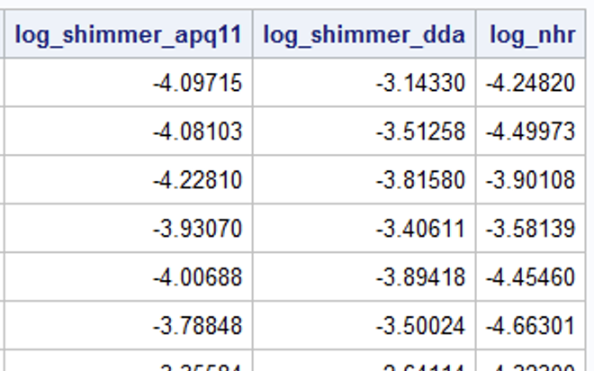

As Jitter and Shimmer values are right skewed, we applied log transform to the variables.

**Scatter Plot**

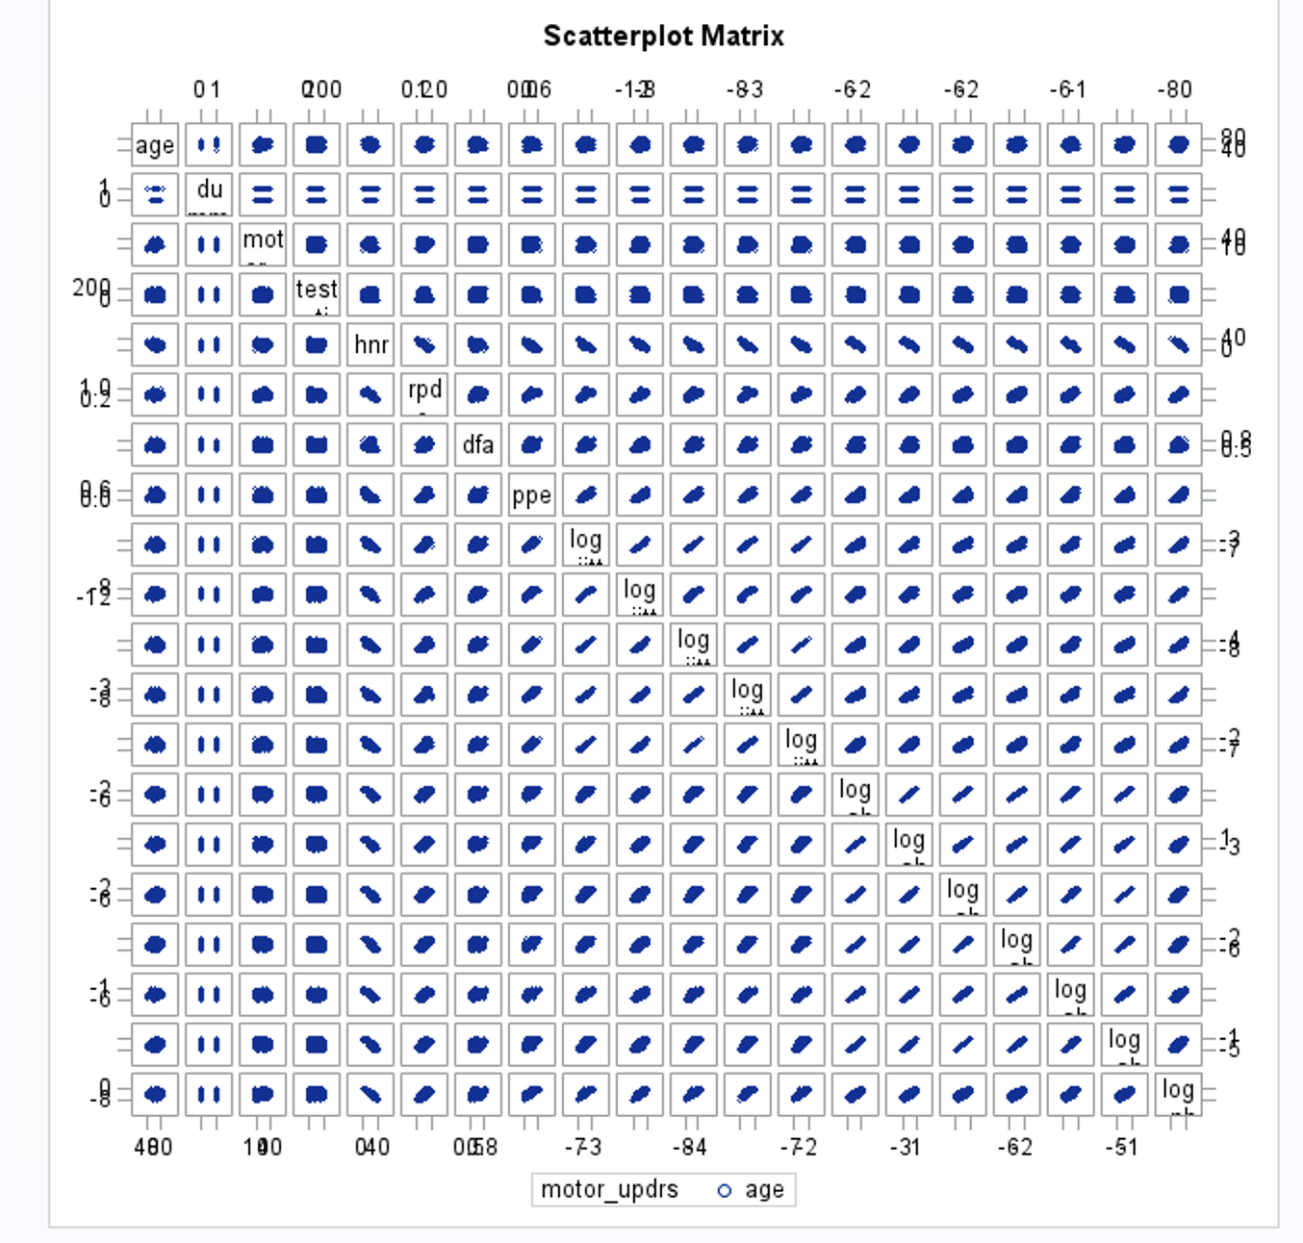

**Pearson Correlation matrix**

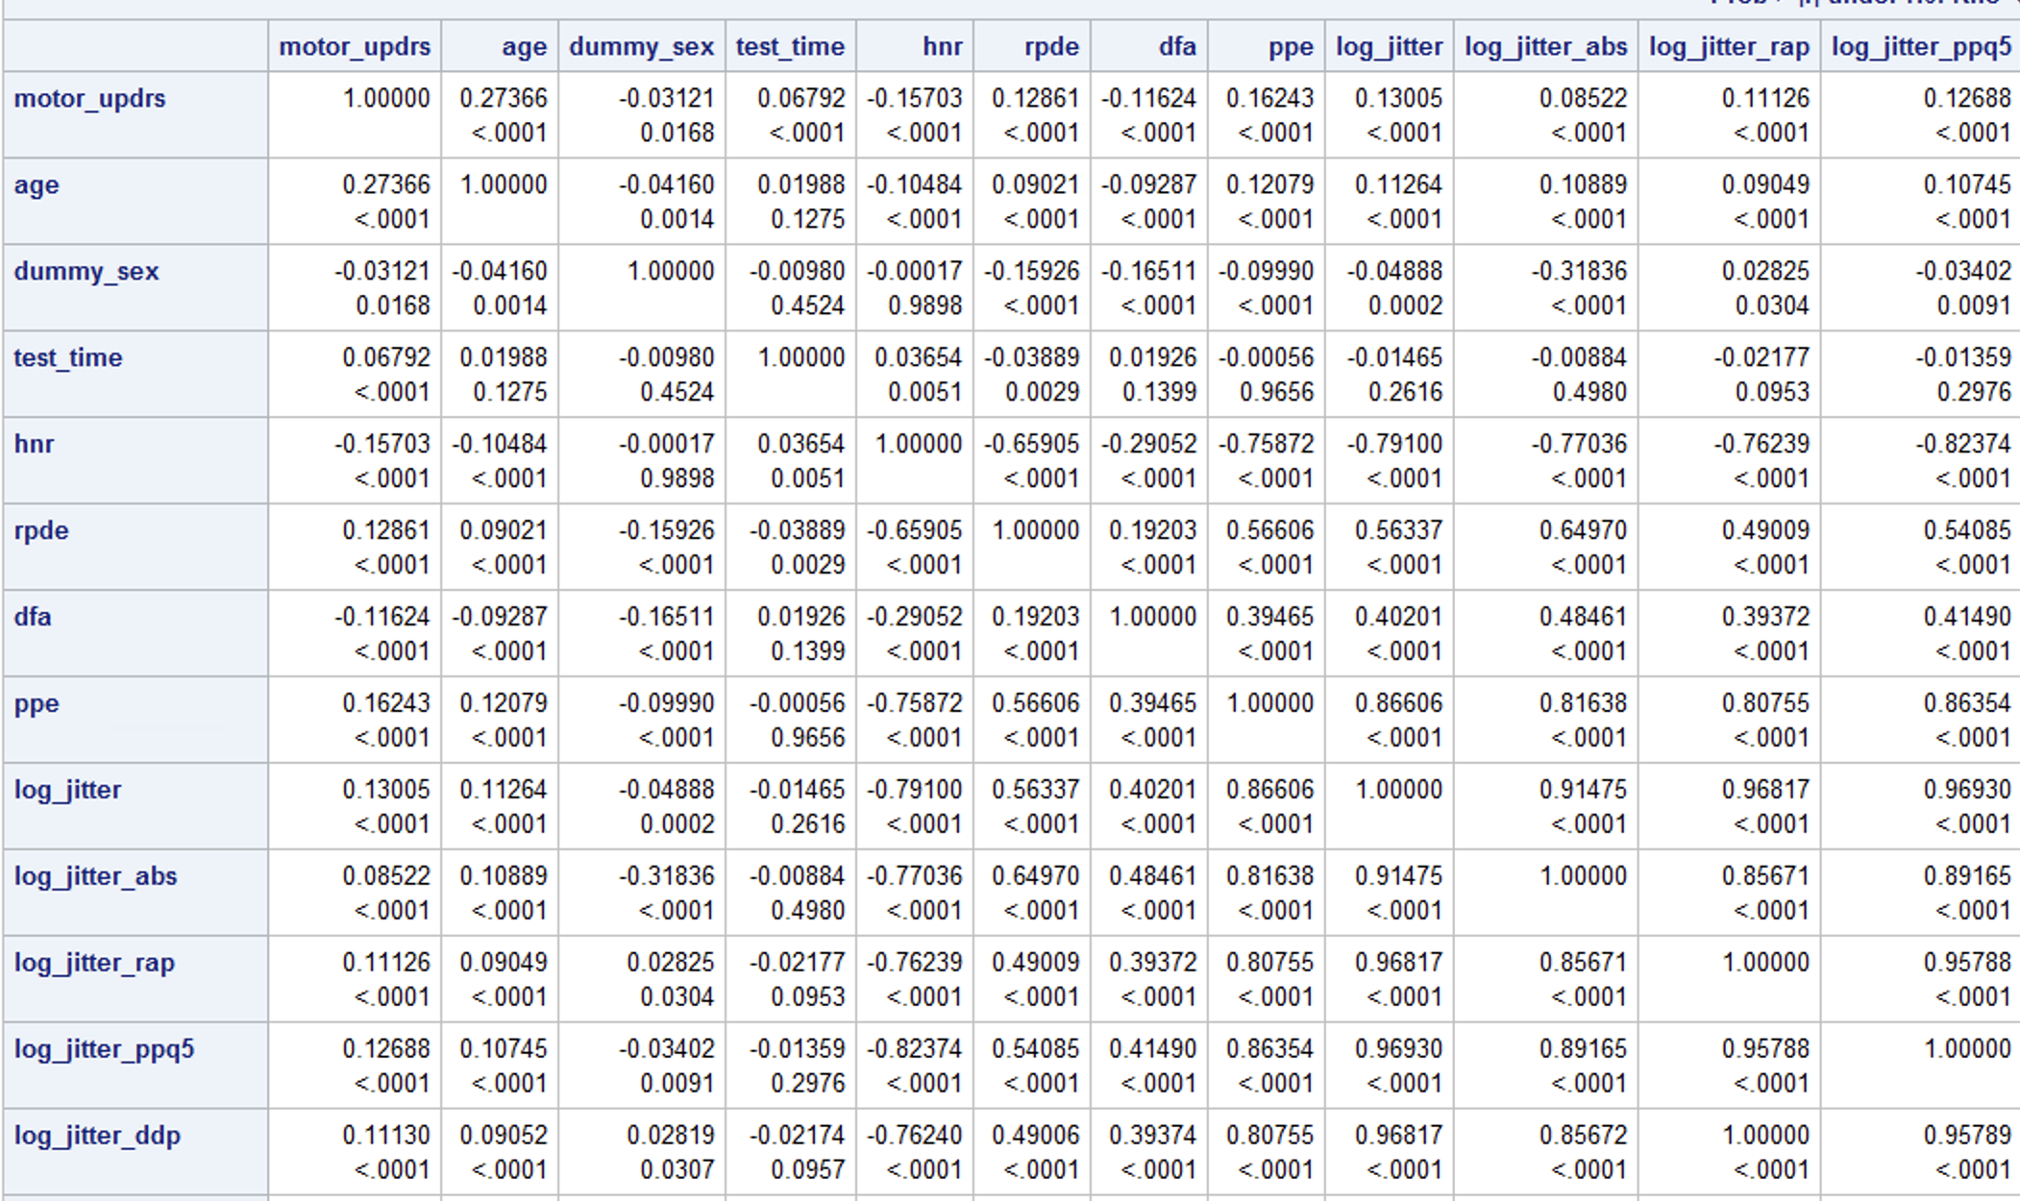

Coorellation:

1. Age (0.27366): There is a positive correlation between age and motor UPDRS score, suggesting that as individuals get older, their motor symptoms tend to worsen. This relationship is statistically significant (p < 0.0001), meaning it is unlikely to have occurred by chance.
2. Dummy_sex (-0.03121): There is a small negative correlation between the dummy variable for sex (presumably male vs. female) and the motor UPDRS score. This suggests that females may have slightly lower motor UPDRS scores on average. However, the effect size is small, and the correlation is relatively weak. The relationship is statistically significant (p = 0.0168), but the clinical significance may be limited.
3. Test_time (0.06792): There is a positive correlation between the test time and the motor UPDRS score. This implies that the longer the duration of the test, the higher the motor UPDRS score tends to be. It is important to note that test time alone may not have a direct causal relationship with the motor UPDRS score but could be indicative of other factors related to disease progression. The correlation is statistically significant (p < 0.0001).
4. Jitter, Jitter_abs, Jitter_rap, Jitter_ppq5, Jitter_ddp: These variables all show positive correlations with the motor UPDRS score. Jitter refers to the variation in the timing of vocal cord vibrations during speech production. Higher values indicate increased vocal instability, which may be associated with motor symptoms in Parkinson's disease. All of these variables have statistically significant correlations (p < 0.0001).
5. Shimmer, Shimmer_db, Shimmer_apq3, Shimmer_apq5, Shimmer_apq11, Shimmer_dda: Similar to jitter, these variables represent measures of vocal instability and voice quality during speech production. They all show positive correlations with the motor UPDRS score, indicating that greater vocal irregularities and shimmer are associated with higher motor UPDRS scores. All of these correlations are statistically significant (p < 0.0001).
6. NHR (0.07497): NHR stands for the noise-to-harmonics ratio, which measures the level of noise in the voice relative to the harmonics. A higher NHR value suggests increased vocal instability. In this case, a higher NHR is associated with a higher motor UPDRS score. The correlation is statistically significant (p < 0.0001).
7. HNR (-0.15703): HNR refers to the harmonics-to-noise ratio, which measures the clarity of the voice. A lower HNR value indicates reduced voice clarity. In this analysis, a lower HNR is associated with a higher motor UPDRS score. The correlation is statistically significant (p < 0.0001).
8. RPDE (0.12861): RPDE stands for the Recurrence Period Density Entropy, which characterizes the regularity of vocal fold vibrations. A higher RPDE value suggests increased irregularity in the voice. In this case, higher RPDE values are positively correlated with higher motor UPDRS scores. The correlation is statistically significant (p < 0.0001).
9. DFA (-0.11624): DFA refers to Detrended Fluctuation Analysis, which measures the presence of long-range correlations in the voice signal. A lower DFA value indicates reduced complexity in the voice signal. In this analysis, lower DFA values are associated with higher motor UPDRS scores. The correlation is statistically significant (p < 0.0001).
10. PPE (0.16243): PPE stands for Pitch Period Entropy, which quantifies the variability of pitch patterns in the voice. A higher PPE value suggests increased pitch variability. In this case, higher PPE values are positively correlated with higher motor UPDRS scores. The correlation is statistically significant (p < 0.0001).

**Model Evaluation and Selection**

**Full model with outliers and influential points**

**Initial model**

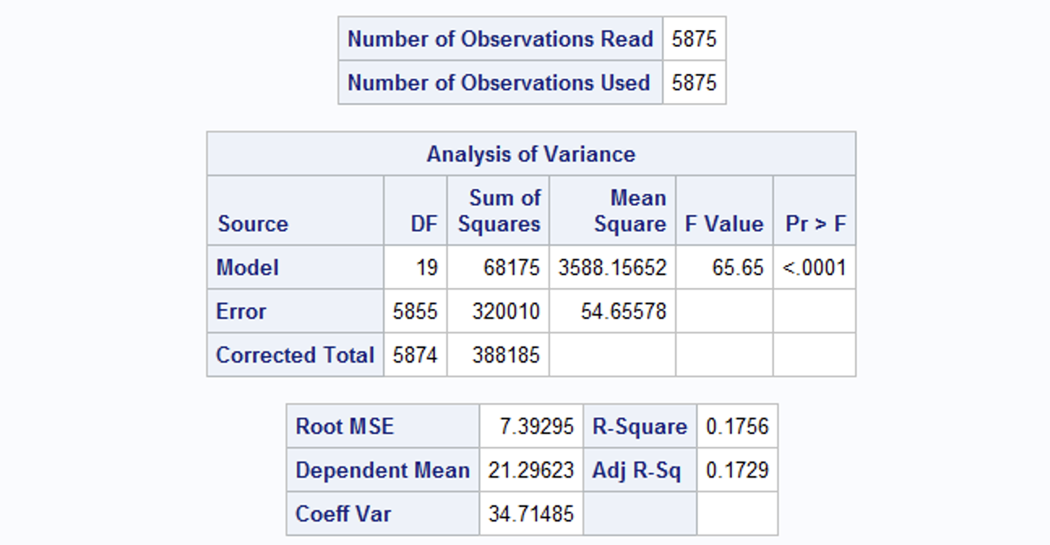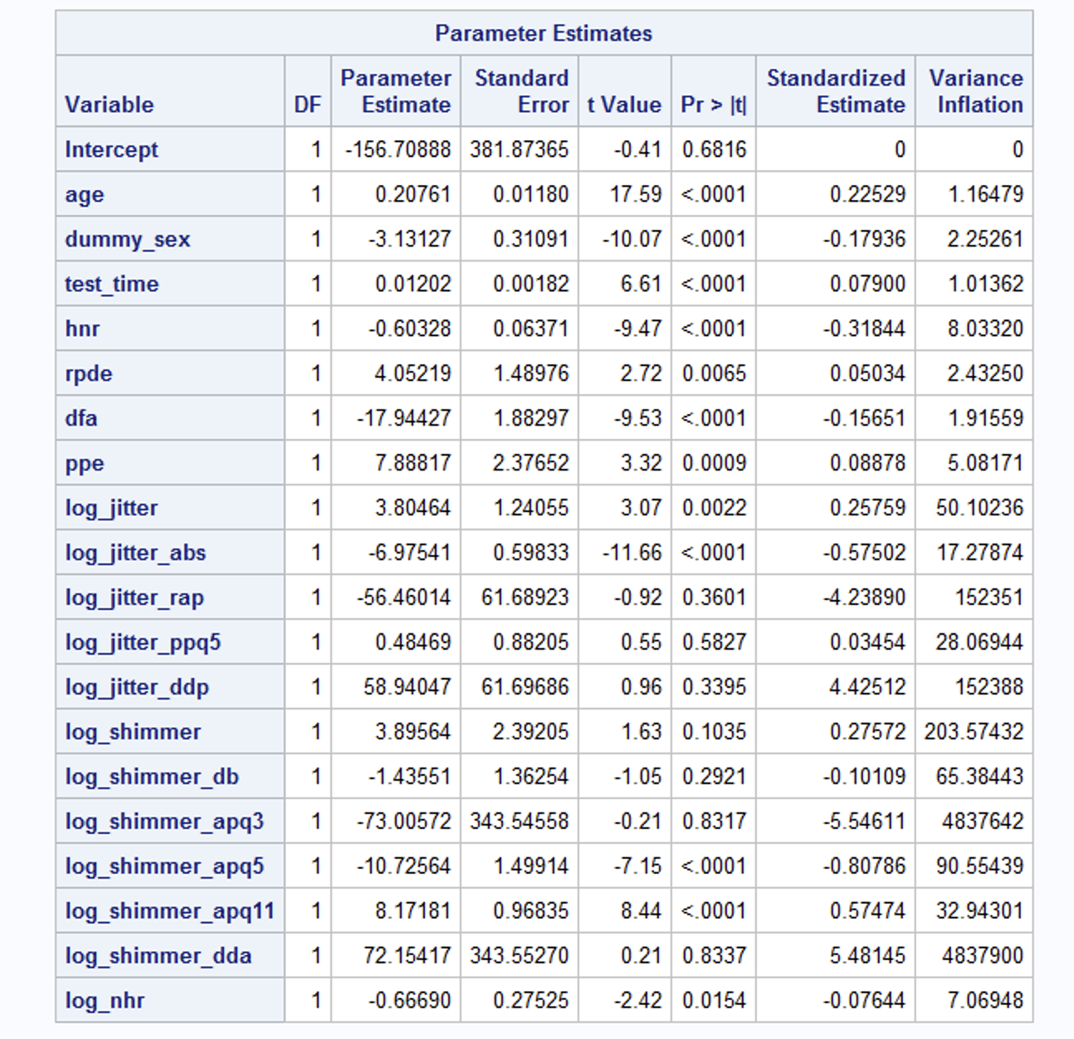

**Forward Selection results**

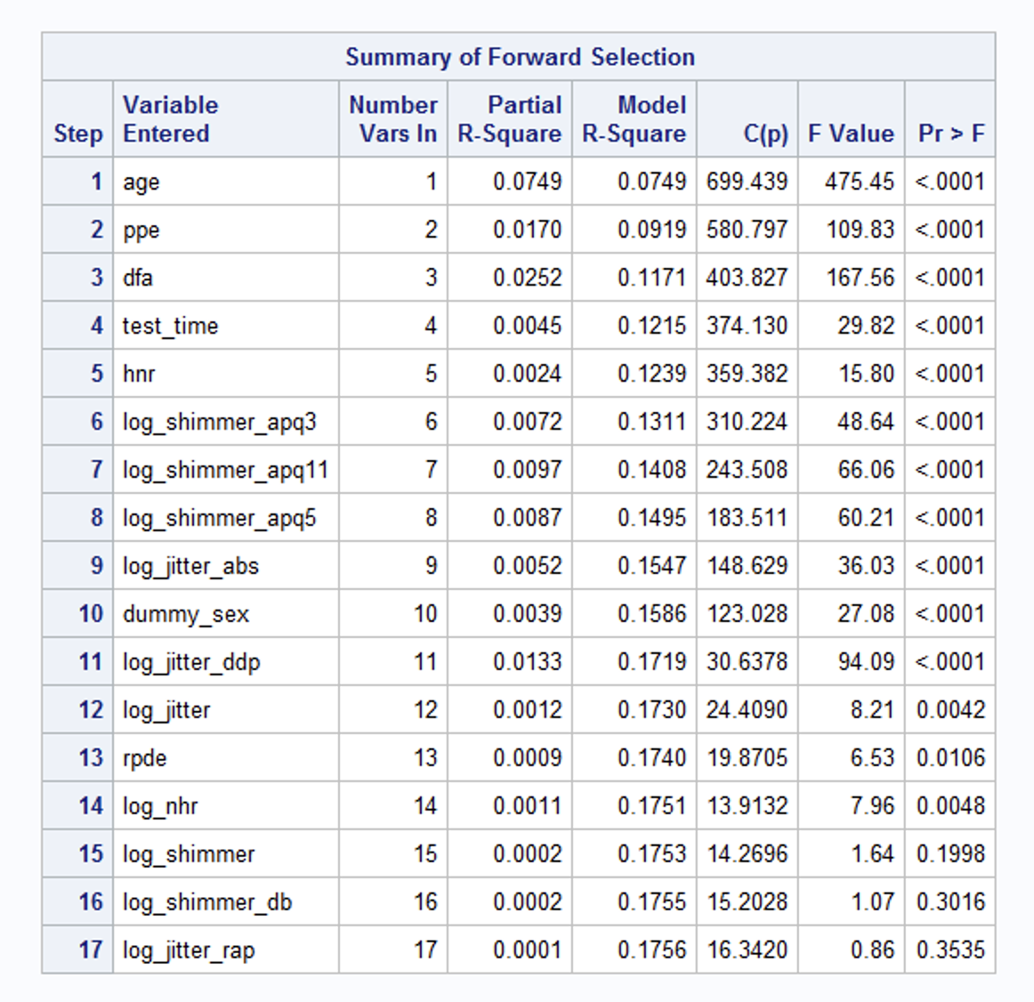

**Backward Selection results**

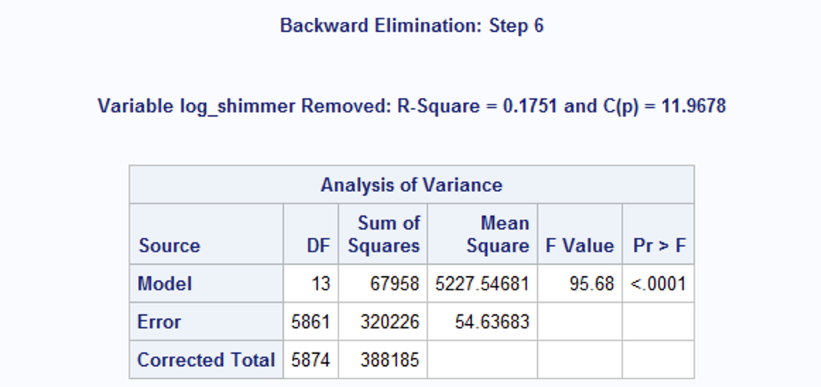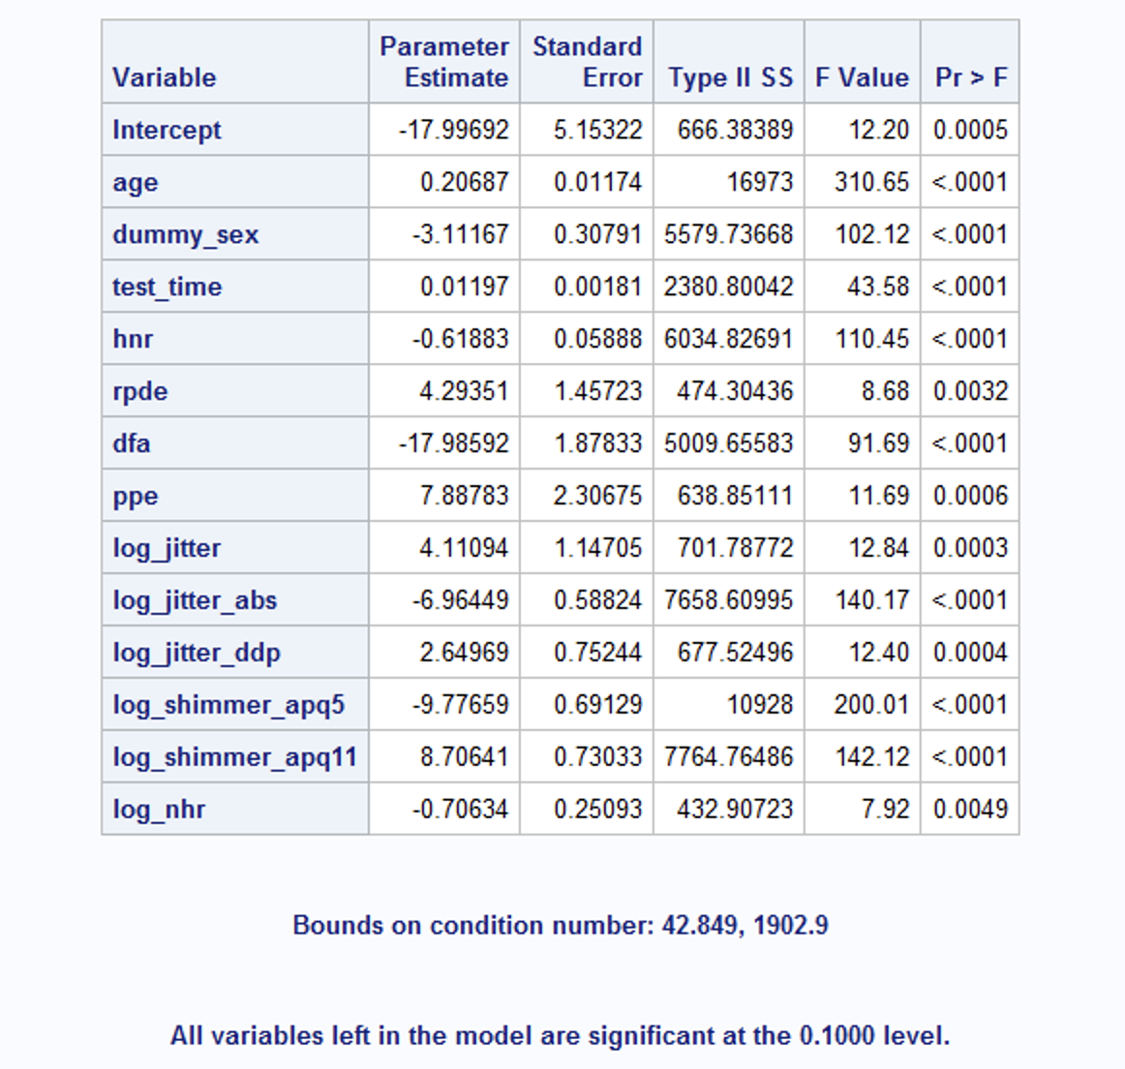

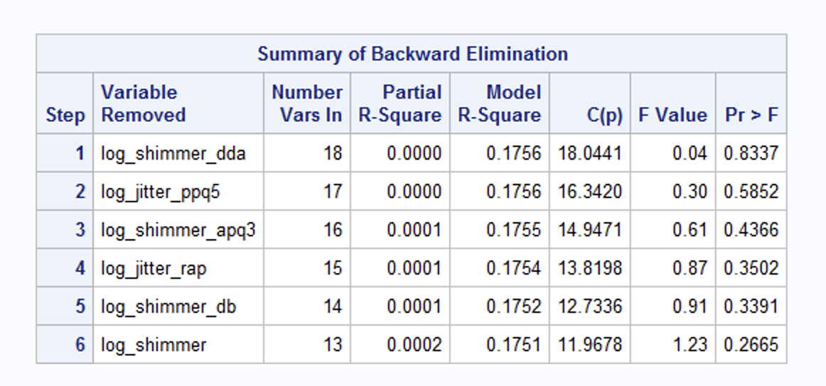

**RSq Selection results**



**Stepwise Selection results**

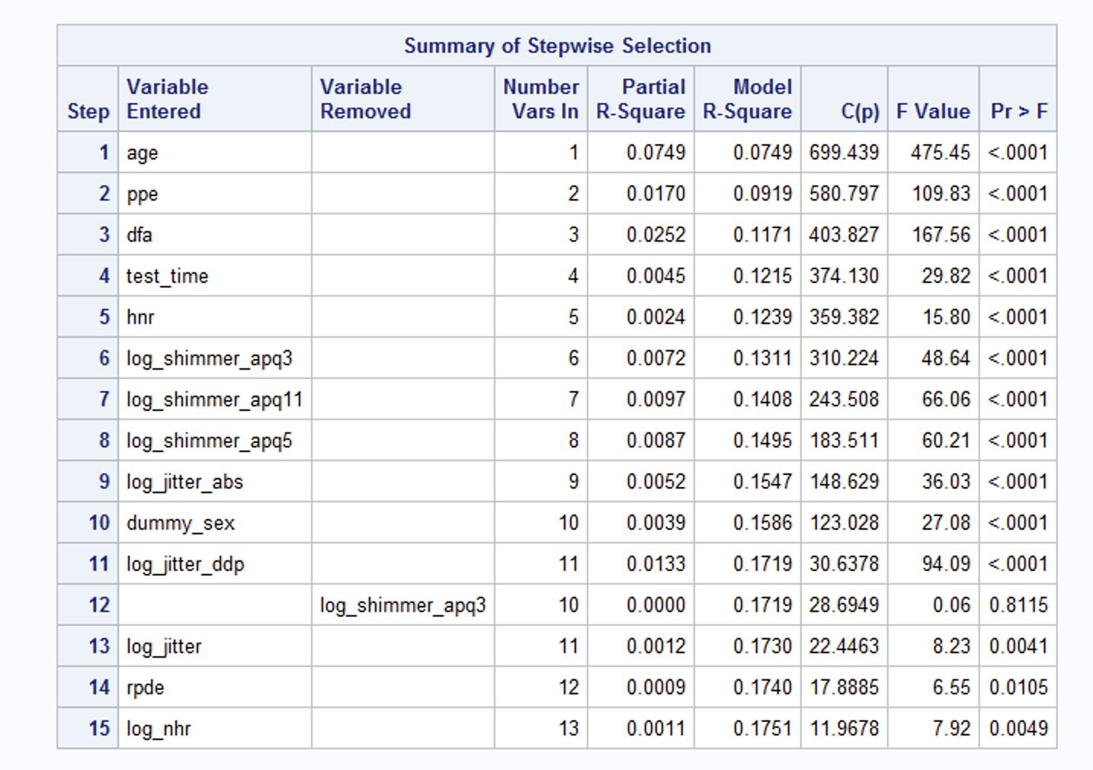

**Cp Selection results**



Based on the above data I considered to remove these variables in sequence

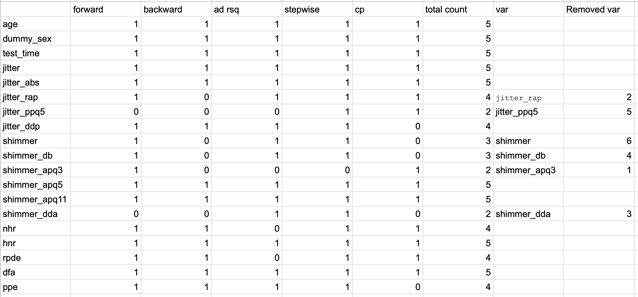

**Model varibale selection based on the p value and VIF**

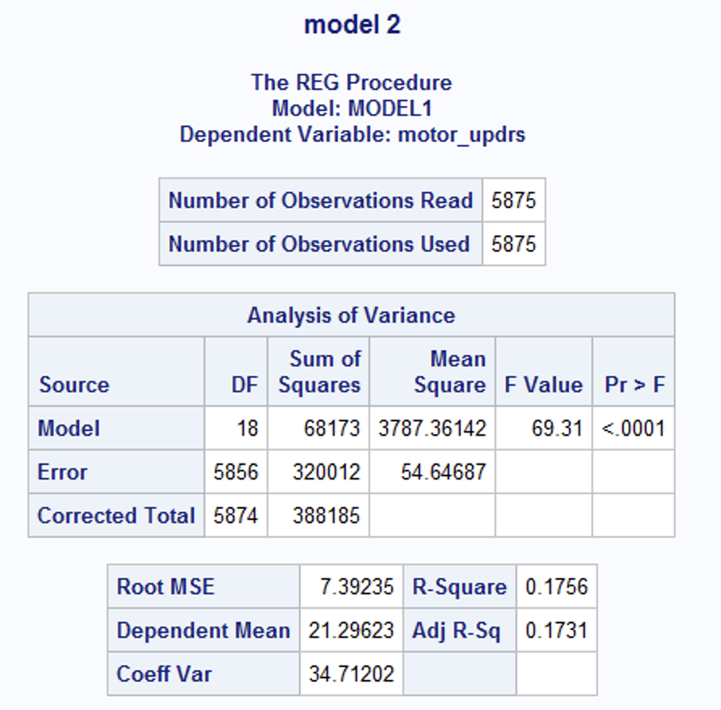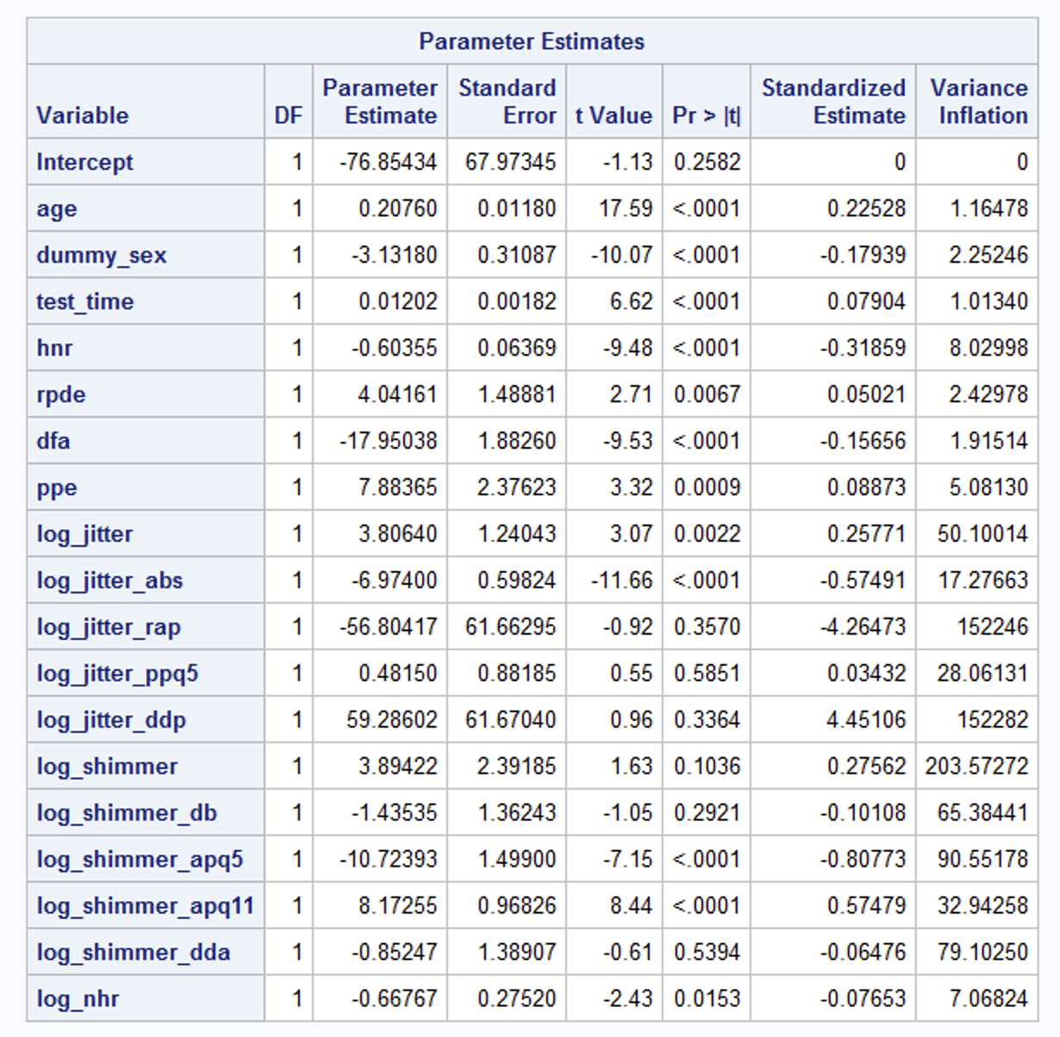

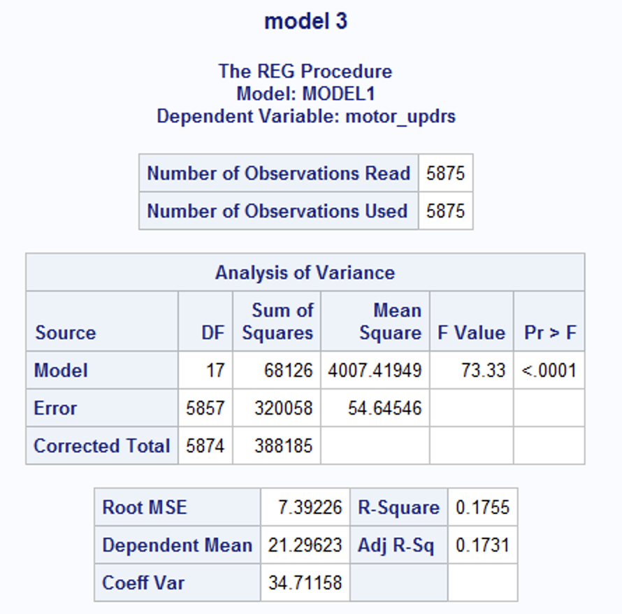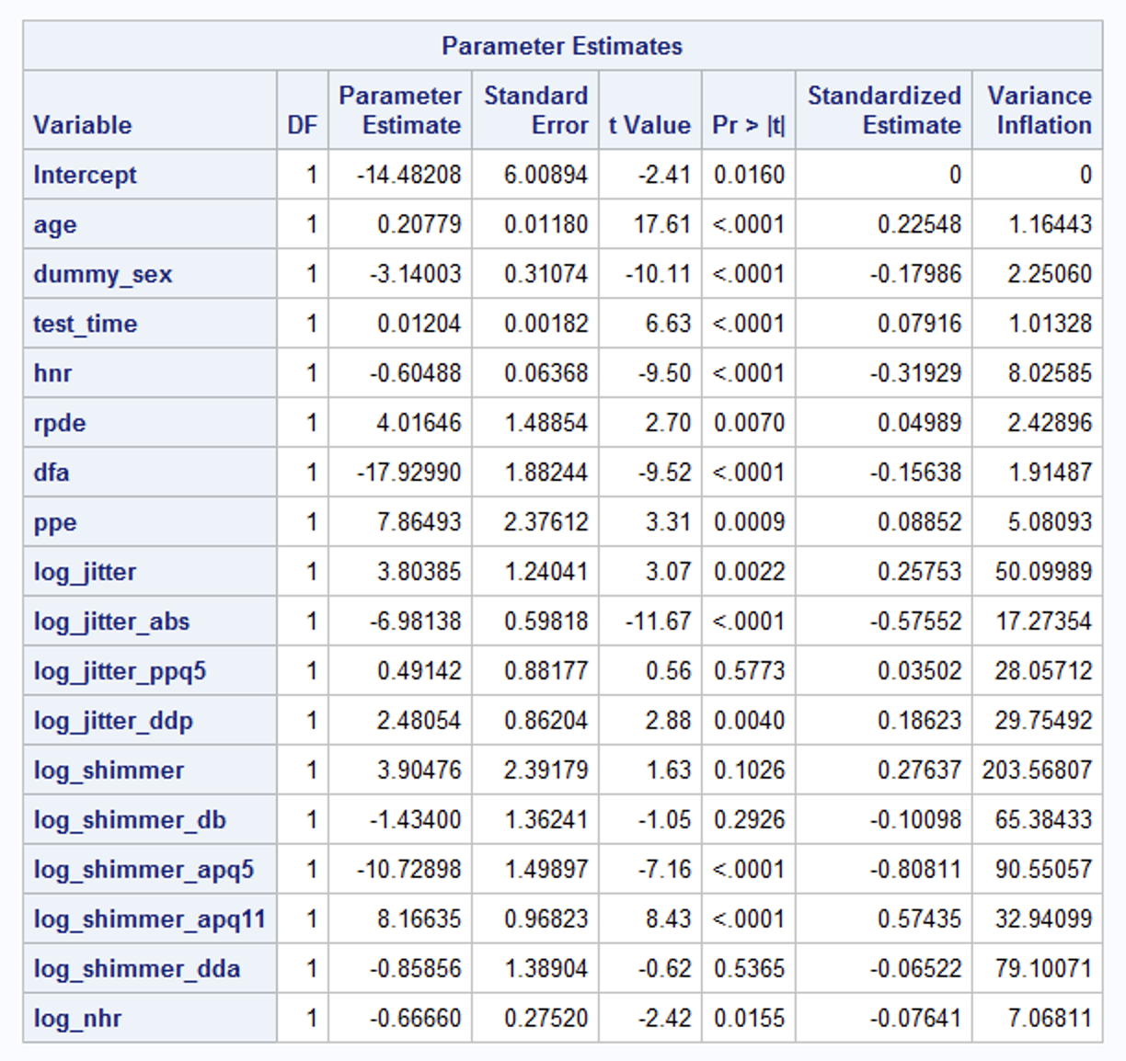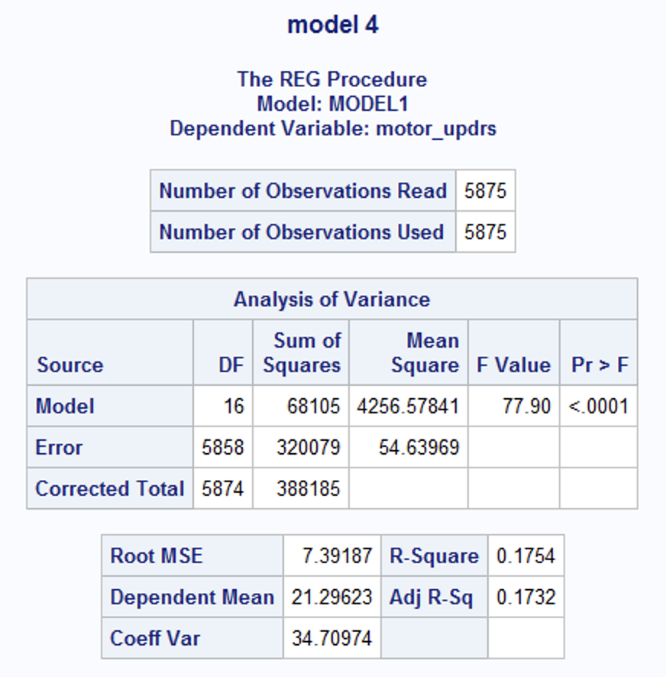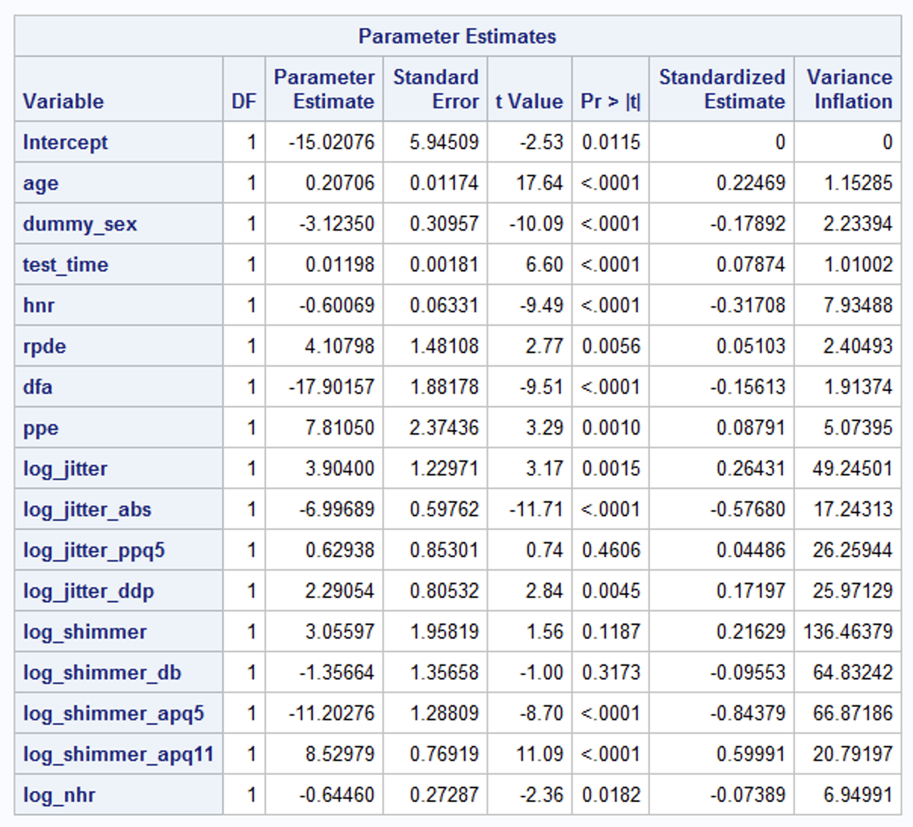

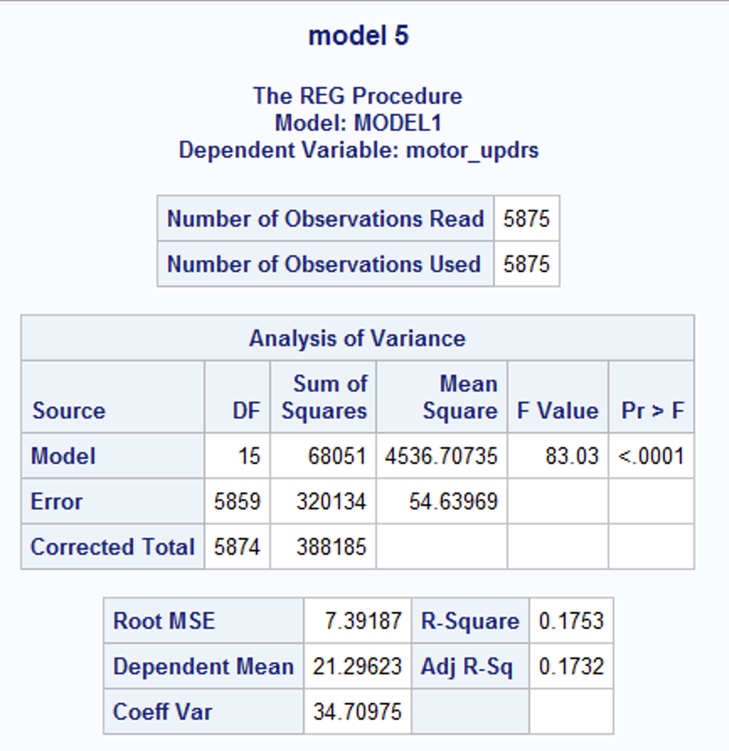

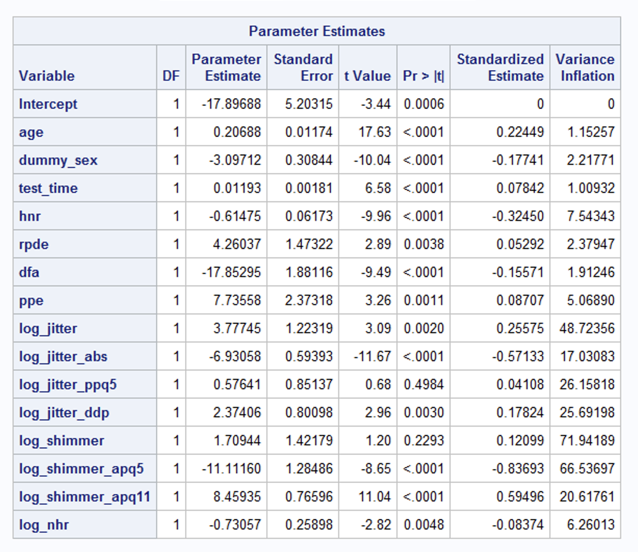

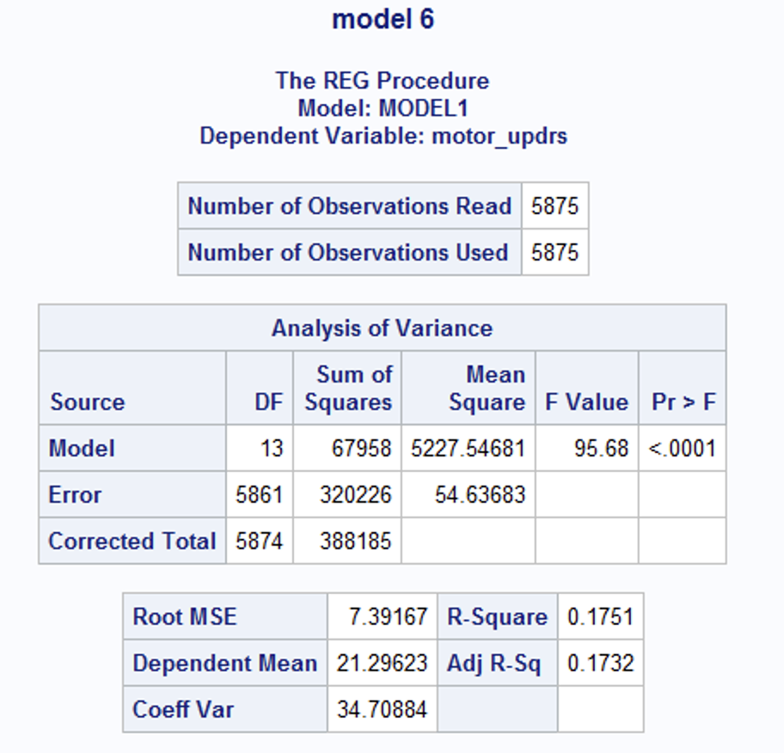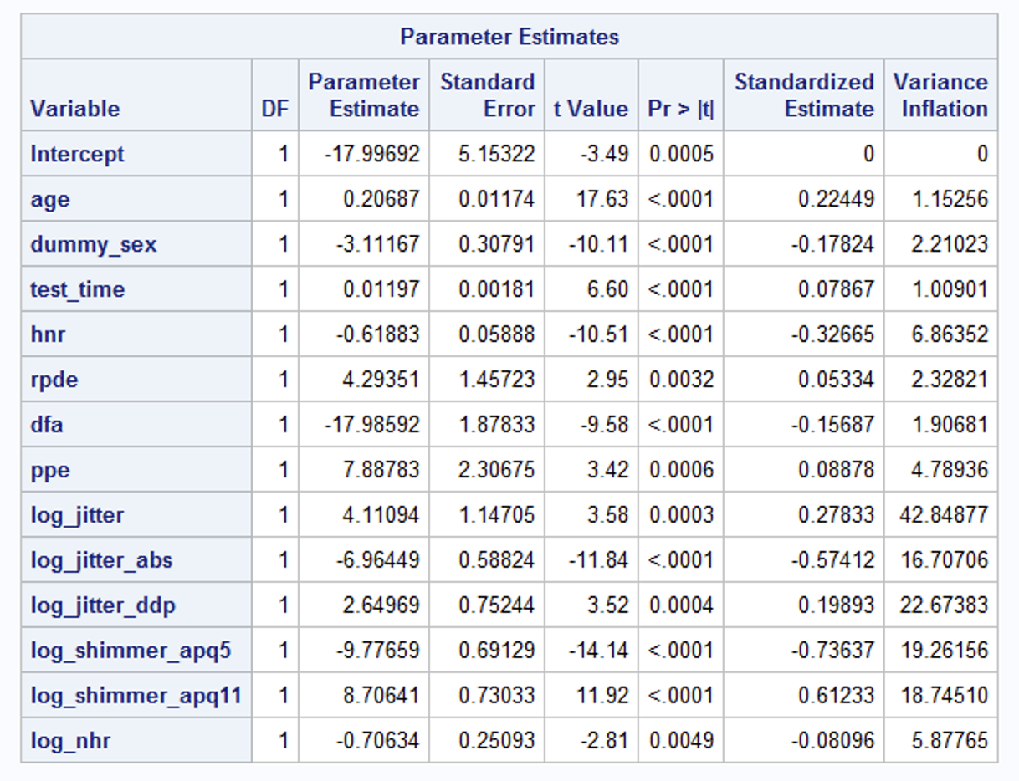

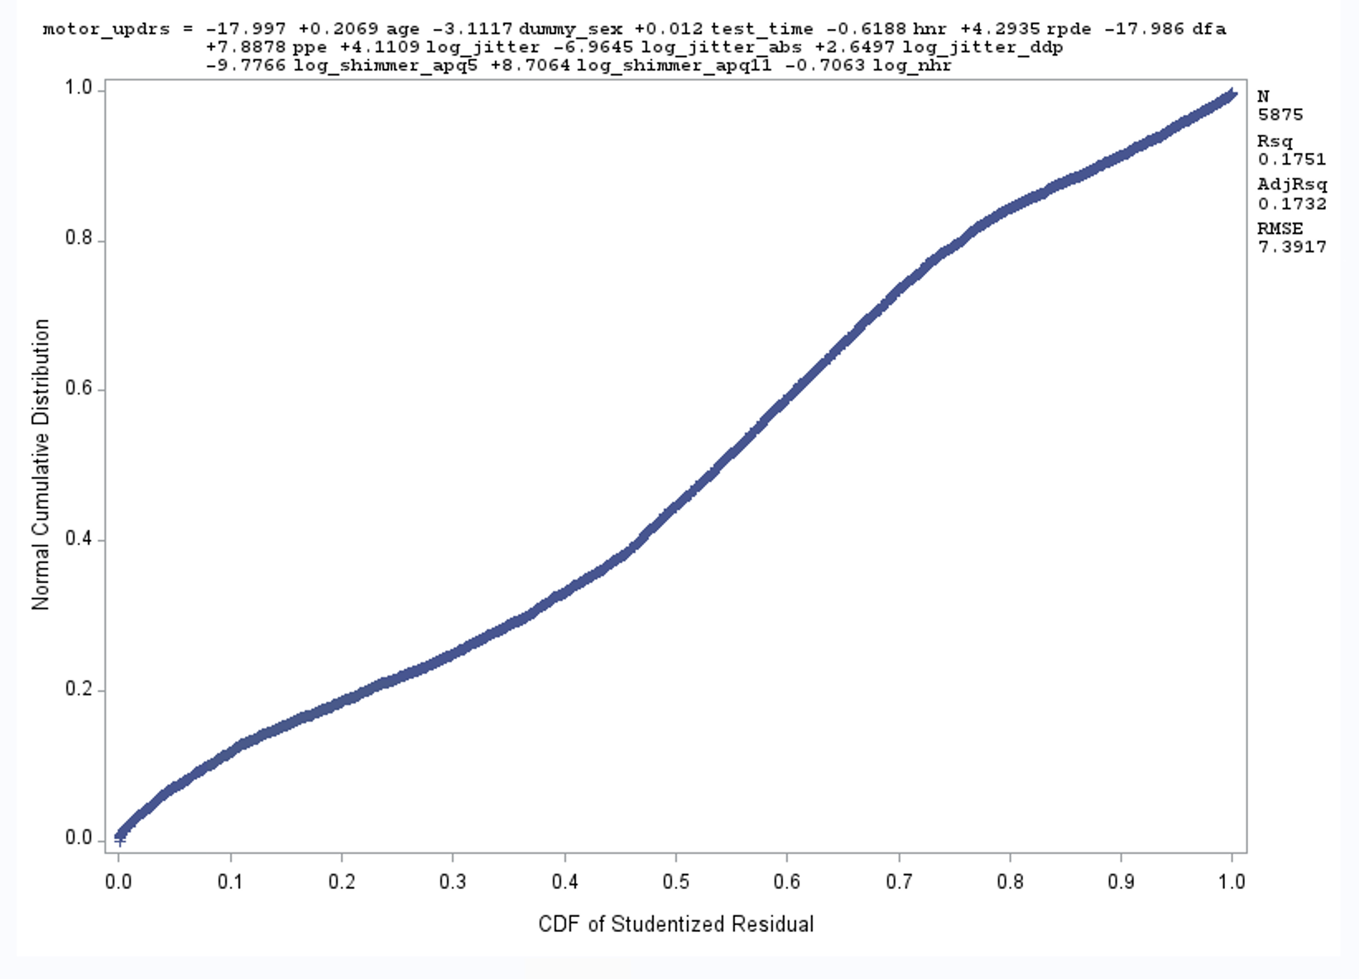

**Final Model**

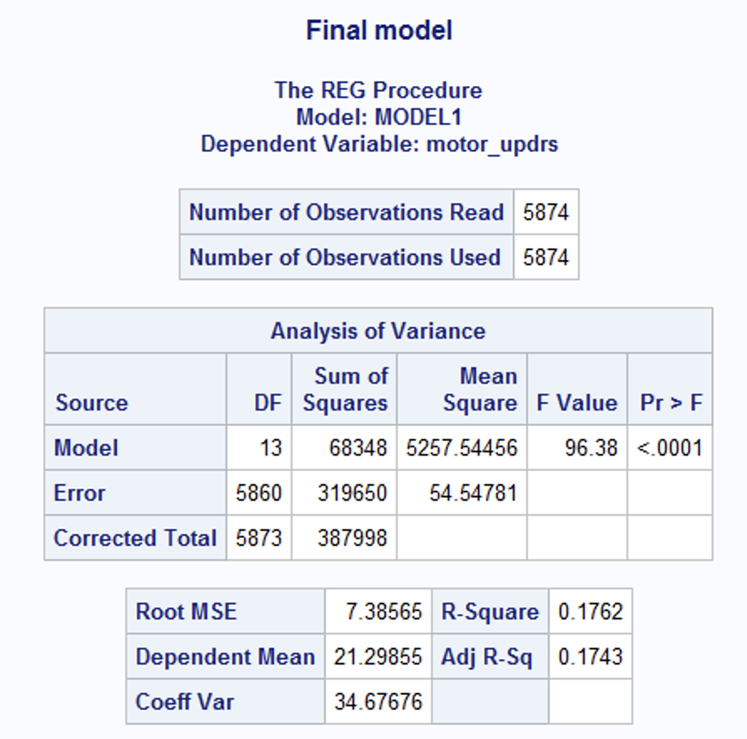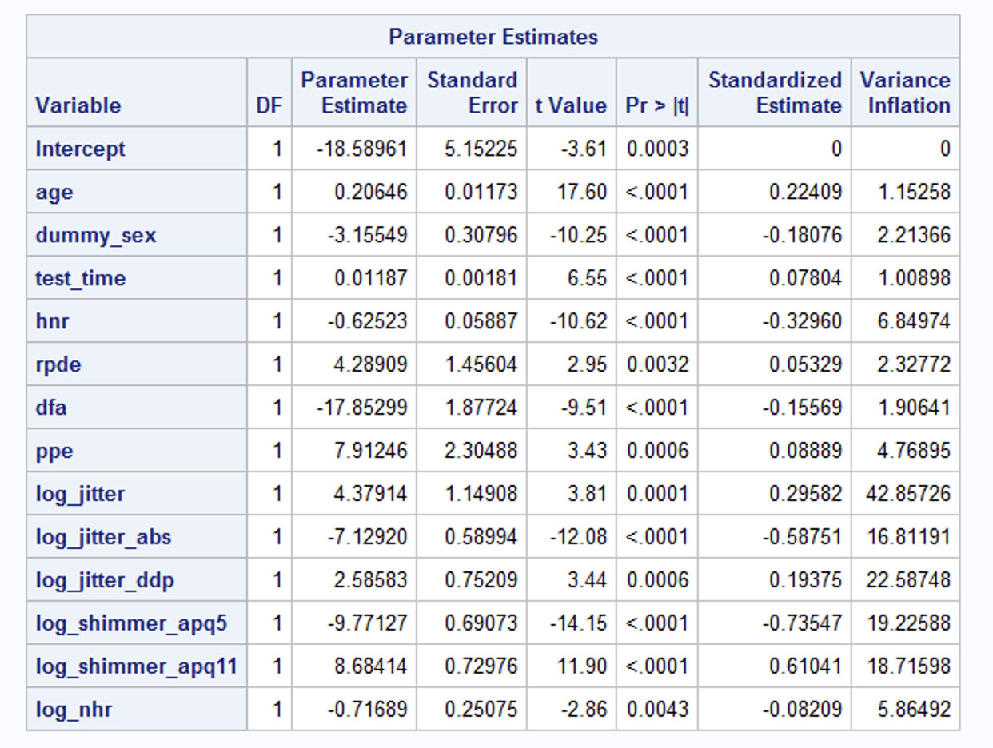

Final model Equation = -18.58961 + 1 * age + 0.20646 * dummy_sex - 3.15549 * test time + 0.01187 * hnr - 0.62523 * rpde dfa + 4.28909 * ppe - 17.85299 * log_jitter + 7.91246 * log_jitter_abs + 4.37914 * log_jitter_ddp + (-7.12920) * log_shimmer_apq5 + 2.58583 * log_shimmer_apq11 - 9.77127 * log_nhr + 8.68414 * DE - 0.71689 * log_shimmer_apq5

**Model Validation**

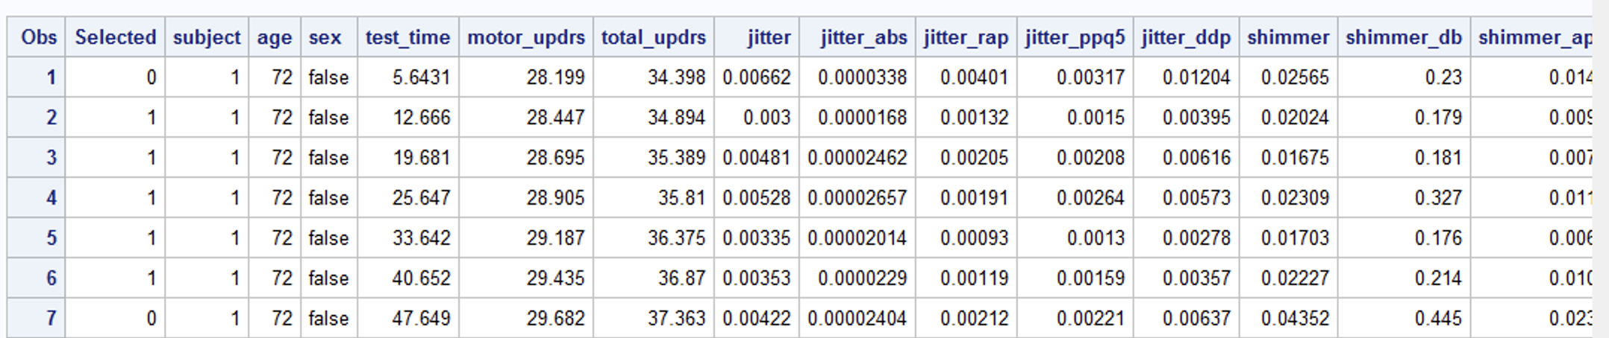

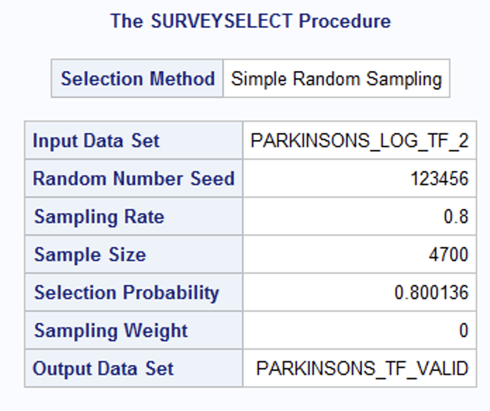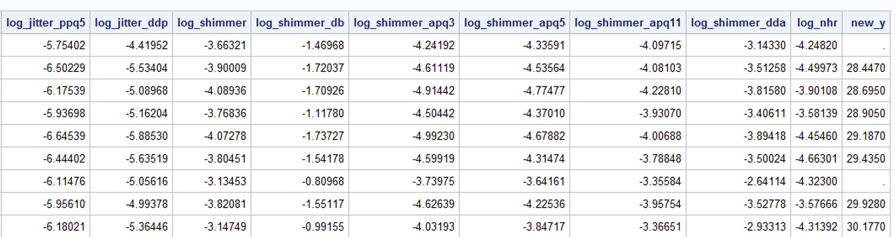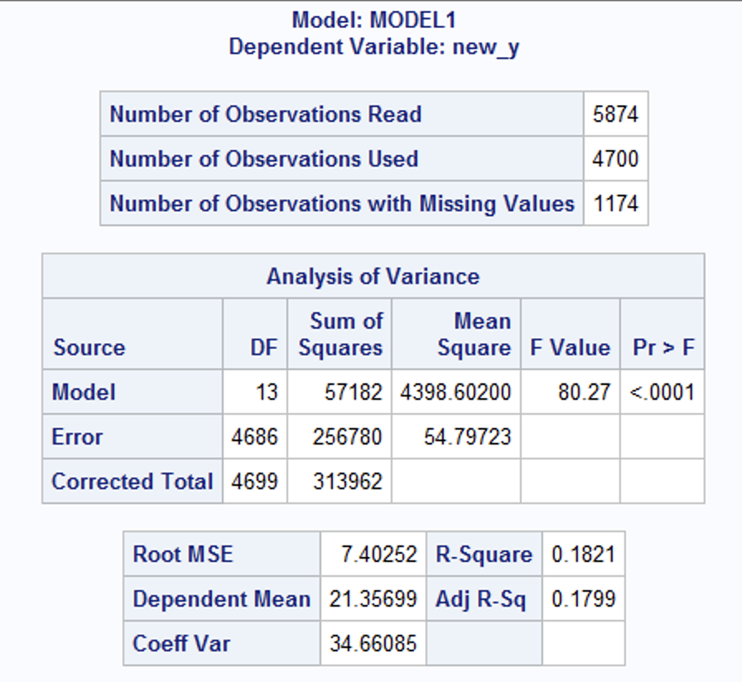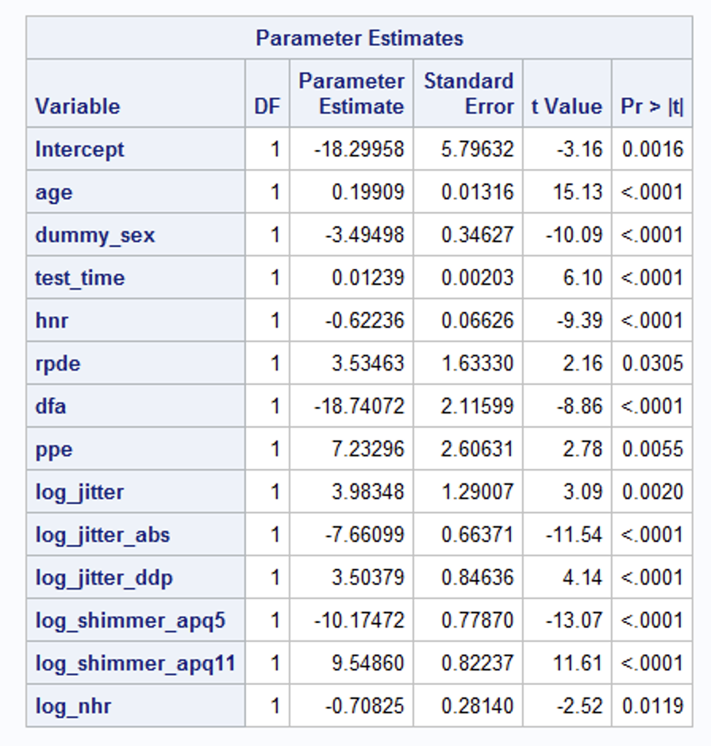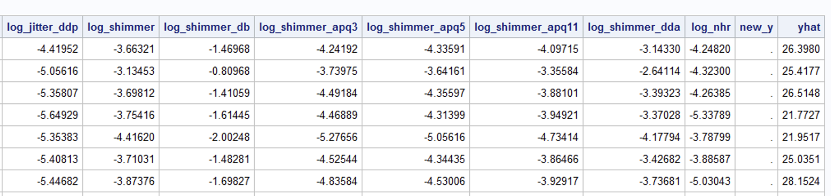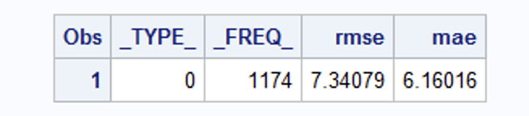

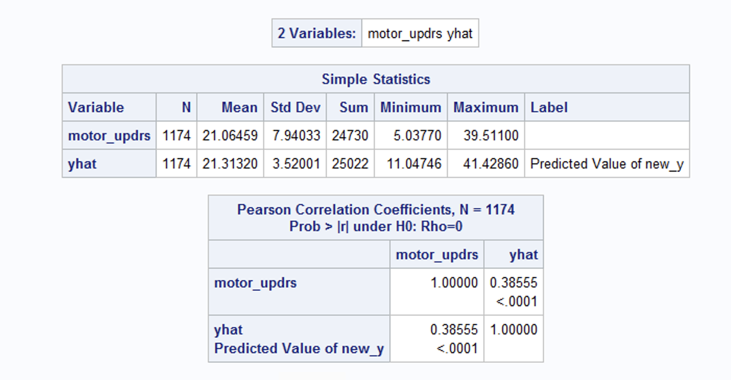

New_y = age dummy_sex test_time hnr rpde dfa ppe log_jitter log_jitter_abs log_jitter_ddp log_shimmer_apq5 log_shimmer_apq11 log_nhr

With Log transform

Train

RMSE = 7.40252

R sq = 0.1821

Adj R sq= 0.1799

GOF = ok

Residuals = ok

Test

RMSE = 7.34079

MAE = 6.16016

R sq = 0.1486

Adj R sq = **0.1478**

**Method 2:** Without log transform

Applied Transformation to

reciprocal_jitter = **1** / jitter;

reciprocal_shimmer = **1** / shimmer;

Final Model :

new_y = age dummy_sex test_time reciprocal_jitter jitter_abs jitter_ppq5 jitter_ddp reciprocal_shimmer shimmer_apq5 shimmer_apq11 nhr hnr dfa ppe;

**data** Parkinsons_dummy_2;

set Parkinsons_dummy;

if _n_ in (**1881**,**4064**) then delete;

**run**;

**data** Parkinsons_dummy_3;

set Parkinsons_dummy_2;

if _n_ in (**4105**) then delete;

**run**;

**data** Parkinsons_dummy_4;

set Parkinsons_dummy_3;

if _n_ in (**4043**) then delete;

**run**;

**data** Parkinsons_tf;

set Parkinsons_dummy_4;

reciprocal_jitter = **1** / jitter;

reciprocal_shimmer = **1** / shimmer;

**run**;

**proc** **reg** data=Parkinsons_tf_valid;

model new_y = age dummy_sex test_time reciprocal_jitter jitter_abs jitter_ppq5 jitter_ddp reciprocal_shimmer shimmer_apq5 shimmer_apq11 nhr hnr dfa ppe;

**run**;

**proc** **reg** data=Parkinsons_tf_valid;

model new_y = age dummy_sex test_time reciprocal_jitter jitter_abs jitter_ppq5 jitter_ddp reciprocal_shimmer shimmer_apq5 shimmer_apq11 nhr hnr dfa ppe;

output out=outml(where=(new_y=**.**)) p=yhat;

**run**;

Train

RMSE = 7.46723

R sq = 0.1676

Adj R sq= 0.1651

GOF = ok

Residuals = ok

Test

RMSE = 7.28530

MAE = 6.08728

R sq = 0.1601

Adj R sq = **0.1593**

**Future Work:**

1. Understanding the variables in depth and considering for VIF
2. Time Step importance

**Code :**

**proc** **import** datafile="Parkinsons-Telemonitoring-ucirvine.csv" out=Parkinsons replace;

delimiter=',';

getnames=yes;

**run**;

**data** Parkinsons_dummy;

set Parkinsons;

dummy_sex = (sex = "true");

**run**;

**proc** **print** data=Parkinsons_dummy;

**run**;

*subject age sex test_time motor_updrs total_updrs jitter jitter_abs jitter_rap jitter_ppq5 jitter_ddp shimmer shimmer_db shimmer_apq3 shimmer_apq5 shimmer_apq11 shimmer_dda nhr hnr rpde dfa ppe;

**proc** **univariate** normal data=Parkinsons_dummy;

var jitter jitter_abs jitter jitter_abs jitter_rap jitter_ppq5 jitter_ddp shimmer shimmer_db shimmer_apq3 shimmer_apq5 shimmer_apq11 shimmer_dda nhr;

histogram ;

**run**;

**data** Parkinsons_log_tf;

set Parkinsons_dummy;

log_jitter = log(jitter);

log_jitter_abs = log(jitter_abs);

log_jitter_rap = log(jitter_rap);

log_jitter_ppq5 = log(jitter_ppq5);

log_jitter_ddp = log(jitter_ddp);

log_shimmer = log(shimmer);

log_shimmer_db = log(shimmer_db);

log_shimmer_apq3 = log(shimmer_apq3);

log_shimmer_apq5 = log(shimmer_apq5);

log_shimmer_apq11 = log(shimmer_apq11);

log_shimmer_dda = log(shimmer_dda);

log_nhr = log(nhr);

**run**;

**proc** **print** data=Parkinsons_log_tf;

**run**;

*age dummy_sex test_time hnr rpde dfa ppe log_jitter log_jitter_abs log_jitter_rap log_jitter_ppq5 log_jitter_ddp log_shimmer log_shimmer_db log_shimmer_apq3 log_shimmer_apq5 log_shimmer_apq11 log_shimmer_dda log_nhr;

**proc** **sgscatter** data=Parkinsons_log_tf;

title "Scatterplot Matrix";

matrix age dummy_sex motor_updrs test_time hnr rpde dfa ppe log_jitter log_jitter_abs log_jitter_rap log_jitter_ppq5 log_jitter_ddp log_shimmer log_shimmer_db log_shimmer_apq3 log_shimmer_apq5 log_shimmer_apq11 log_shimmer_dda log_nhr / group= motor_updrs;

**run**;

**proc** **corr** data=Parkinsons_log_tf;

var motor_updrs age dummy_sex test_time hnr rpde dfa ppe log_jitter log_jitter_abs log_jitter_rap log_jitter_ppq5 log_jitter_ddp log_shimmer log_shimmer_db log_shimmer_apq3 log_shimmer_apq5 log_shimmer_apq11 log_shimmer_dda log_nhr;

**run**;

*VIF stb 1 ;

**PROC** **REG** data=Parkinsons_log_tf;

MODEL motor_updrs = age dummy_sex test_time hnr rpde dfa ppe log_jitter log_jitter_abs log_jitter_rap log_jitter_ppq5 log_jitter_ddp log_shimmer log_shimmer_db log_shimmer_apq3 log_shimmer_apq5 log_shimmer_apq11 log_shimmer_dda log_nhr/stb vif;

**RUN**;

*Forward-Selection method;

**PROC** **REG** data=Parkinsons_log_tf;

MODEL motor_updrs = age dummy_sex test_time hnr rpde dfa ppe log_jitter log_jitter_abs log_jitter_rap log_jitter_ppq5 log_jitter_ddp log_shimmer log_shimmer_db log_shimmer_apq3 log_shimmer_apq5 log_shimmer_apq11 log_shimmer_dda log_nhr /selection = forward;

*Backward-Selection method;

MODEL motor_updrs = age dummy_sex test_time hnr rpde dfa ppe log_jitter log_jitter_abs log_jitter_rap log_jitter_ppq5 log_jitter_ddp log_shimmer log_shimmer_db log_shimmer_apq3 log_shimmer_apq5 log_shimmer_apq11 log_shimmer_dda log_nhr /selection = backward;

*Adiusted R-2 selection method;

MODEL motor_updrs = age dummy_sex test_time hnr rpde dfa ppe log_jitter log_jitter_abs log_jitter_rap log_jitter_ppq5 log_jitter_ddp log_shimmer log_shimmer_db log_shimmer_apq3 log_shimmer_apq5 log_shimmer_apq11 log_shimmer_dda log_nhr /SELECTION = ADJRSQ;

*stepwise selection;

MODEL motor_updrs = age dummy_sex test_time hnr rpde dfa ppe log_jitter log_jitter_abs log_jitter_rap log_jitter_ppq5 log_jitter_ddp log_shimmer log_shimmer_db log_shimmer_apq3 log_shimmer_apq5 log_shimmer_apq11 log_shimmer_dda log_nhr /SELECTION = STEPWISE;

*CP selection method;

MODEL motor_updrs = age dummy_sex test_time hnr rpde dfa ppe log_jitter log_jitter_abs log_jitter_rap log_jitter_ppq5 log_jitter_ddp log_shimmer log_shimmer_db log_shimmer_apq3 log_shimmer_apq5 log_shimmer_apq11 log_shimmer_dda log_nhr /SELECTION = CP;

**RUN**;

*VIF stb 2 ;

**PROC** **REG** data=Parkinsons_log_tf;

title "model 2";

MODEL motor_updrs = age dummy_sex test_time hnr rpde dfa ppe log_jitter log_jitter_abs log_jitter_rap log_jitter_ppq5 log_jitter_ddp log_shimmer log_shimmer_db log_shimmer_apq5 log_shimmer_apq11 log_shimmer_dda log_nhr/stb vif;

**RUN**;

*VIF stb 3 ;

**PROC** **REG** data=Parkinsons_log_tf;

title "model 3";

MODEL motor_updrs = age dummy_sex test_time hnr rpde dfa ppe log_jitter log_jitter_abs log_jitter_ppq5 log_jitter_ddp log_shimmer log_shimmer_db log_shimmer_apq5 log_shimmer_apq11 log_shimmer_dda log_nhr/stb vif;

**RUN**;

*VIF stb 4 ;

**PROC** **REG** data=Parkinsons_log_tf;

title "model 4";

MODEL motor_updrs = age dummy_sex test_time hnr rpde dfa ppe log_jitter log_jitter_abs log_jitter_ppq5 log_jitter_ddp log_shimmer log_shimmer_db log_shimmer_apq5 log_shimmer_apq11 log_nhr/stb vif;

**RUN**;

*VIF stb 5 ;

**PROC** **REG** data=Parkinsons_log_tf;

title "model 5";

MODEL motor_updrs = age dummy_sex test_time hnr rpde dfa ppe log_jitter log_jitter_abs log_jitter_ppq5 log_jitter_ddp log_shimmer log_shimmer_apq5 log_shimmer_apq11 log_nhr/stb vif;

**RUN**;

*VIF stb 6 ;

**PROC** **REG** data=Parkinsons_log_tf;

title "model 6";

MODEL motor_updrs = age dummy_sex test_time hnr rpde dfa ppe log_jitter log_jitter_abs log_jitter_ddp log_shimmer_apq5 log_shimmer_apq11 log_nhr/stb vif;

**RUN**;

**PROC** **REG** data=Parkinsons_log_tf;

model motor_updrs = age dummy_sex test_time hnr rpde dfa ppe log_jitter log_jitter_abs log_jitter_ddp log_shimmer_apq5 log_shimmer_apq11 log_nhr/ r influence vif;

plot student.*predicted.;

plot student.*(age dummy_sex test_time hnr rpde dfa ppe log_jitter log_jitter_abs log_jitter_ddp log_shimmer_apq5 log_shimmer_apq11 log_nhr);

plot npp.*student.;

**run**;

**data** Parkinsons_log_tf_2;

set Parkinsons_log_tf;

if _n_ in (**1881**) then delete;

**run**;

/*

* without log transform 1881,4064,4105,4043

data Parkinsons_dummy_3;

set Parkinsons_dummy_2;

if _n_ in (4105) then delete;

run;

data Parkinsons_dummy_4;

set Parkinsons_dummy_3;

if _n_ in (4043) then delete;

run;*/

/*

proc reg data=Parkinsons_log_tf_2;

model motor_updrs = age dummy_sex test_time hnr rpde dfa ppe log_jitter log_jitter_abs log_jitter_ddp log_shimmer_apq5 log_shimmer_apq11 log_nhr/ r influence vif;

output out=reg_output rstudent=student_r;

plot student.*predicted.;

plot student.*(age dummy_sex test_time hnr rpde dfa ppe log_jitter log_jitter_abs log_jitter_ddp log_shimmer_apq5 log_shimmer_apq11 log_nhr);

plot npp.*student.;

run;

data rstudent_gt3;

set reg_output;

if abs(student_r) > 3 then output;

run;

proc print data=rstudent_gt3;

run;*/

*Final model;

**PROC** **REG** data=Parkinsons_log_tf_2;

title "Final model";

model motor_updrs = age dummy_sex test_time hnr rpde dfa ppe log_jitter log_jitter_abs log_jitter_ddp log_shimmer_apq5 log_shimmer_apq11 log_nhr/ stb vif;

**RUN**;

*split 80%;

**proc** **surveyselect** data=Parkinsons_log_tf_2 out=Parkinsons_tf_valid seed=**123456**

samprate=**0.80** outall;

**run**;

**proc** **print** data=Parkinsons_tf_valid;

**run**;

*create new_y;

**data** Parkinsons_tf_valid;

set Parkinsons_tf_valid;

if Selected then new_y=motor_updrs;

**run**;

**proc** **print** data=Parkinsons_tf_valid;

**run**;

*train;

**proc** **reg** data=Parkinsons_tf_valid;

model new_y = age dummy_sex test_time hnr rpde dfa ppe log_jitter log_jitter_abs log_jitter_ddp log_shimmer_apq5 log_shimmer_apq11 log_nhr;

**run**;

*test;

**proc** **reg** data=Parkinsons_tf_valid;

model new_y = age dummy_sex test_time hnr rpde dfa ppe log_jitter log_jitter_abs log_jitter_ddp log_shimmer_apq5 log_shimmer_apq11 log_nhr;

output out=outml(where=(new_y=**.**)) p=yhat;

**run**;

**proc** **print** data=outml;

**run**;

**data** outml_sum;

set outml;

diff=motor_updrs-yhat;

absd=abs(diff);

**run**;

**proc** **summary** data=outml_sum;

var diff absd;

output out=outml_stat std(diff)=rmse mean(absd)=mae;

**run**;

**proc** **print** data=outml_stat;

**run**;

**proc** **corr** data=outml;

var motor_updrs yhat;

**run**;